The term “descriptive statistics” refers to the **analysis, summary, and presentation of findings** related to a data set derived from a sample or entire population. Descriptive statistics comprises three main categories –

**Frequency Distribution**

**Measures of Central Tendency**

**and Measures of Variability**.

**Descriptive statistics**

visualization.

presented in a meaningful and understandable way

Frequency Distribution

Used for both quantitative and qualitative data, frequency distribution depicts the frequency or count of the different outcomes in a data set or sample. The frequency distribution is normally presented in a table or a graph. Each entry in the table or graph is accompanied by the count or frequency of the values’ occurrences in an interval, range, or specific group.

Frequency distribution is basically a presentation or summary of grouped data categorized based on mutually exclusive classes and the number of occurrences in each respective class. It allows for a more structured and organized way to present raw data.

Common charts and graphs used in frequency distribution presentation and visualization include bar charts, histograms, pie charts, and line charts.

A frequency distribution is a representation, either in a graphical or tabular format, that displays the number of observations within a given interval. The interval size depends on the data being analyzed and the goals of the analyst. The intervals must be mutually exclusive and exhaustive. Frequency distributions are typically used within a statistical context. Generally, frequency distributions can be associated with the charting of a normal distribution.

KEY TAKEAWAYS

A frequency distribution in statistics is a representation that displays the number of observations within a given interval.

The representation of a frequency distribution can be graphical or tabular so that it is easier to understand.

Frequency distributions are particularly useful for normal distributions, which show the observations of probabilities divided among standard deviations.

In finance, traders use frequency distributions to take note of price action and identify trends.

Understanding a Frequency Distribution

As a statistical tool, a frequency distribution provides a visual representation of the distribution of observations within a particular test. Analysts often use a frequency distribution to visualize or illustrate the data collected in a sample. For example, the height of children can be split into several different categories or ranges.

In measuring the height of 50 children, some are tall and some are short, but there is a high probability of a higher frequency or concentration in the middle range. The most important factors for gathering data are that the intervals used must not overlap and must contain all of the possible observations.

Visual Representation of a Frequency Distribution

Both histograms and bar charts provide a visual display using columns, with the y-axis representing the frequency count, and the x-axis representing the variable to be measured. In the height of children, for example, the y-axis is the number of children, and the x-axis is the height. The columns represent the number of children observed with heights measured in each interval.

In general, a histogram chart will typically show a normal distribution, which means that the majority of occurrences will fall in the middle columns. Frequency distributions can be a key aspect of charting normal distributions which show observation probabilities divided among standard deviations.

Frequency distributions can be presented as a frequency table, a histogram, or a bar chart. Below is an example of a frequency distribution as a table.

Height of Children in a School

Interval (Height) 4' 4'5" 5' 5'2"

Frequency 2 5 6 3

Frequency Distribution in Trading

Frequency distributions are not commonly used in the world of investments; however, traders who follow Richard D. Wyckoff, a pioneering early 20th-century trader, use an approach to trading that involves frequency distribution.

Investment houses still use the approach, which requires considerable practice, to teach traders. The frequency chart is referred to as a point-and-figure chart and was created out of a need for floor traders to take note of price action and to identify trends.1

The y-axis is the variable measured, and the x-axis is the frequency count. Each change in price action is denoted in Xs and Os. Traders interpret it as an uptrend when three X's emerge; in this case, demand has overcome supply. In the reverse situation, when the chart shows three O's, it indicates that supply has overcome demand.1

What Are the Types of Frequency Distribution?

The types of frequency distribution are grouped frequency distribution, ungrouped frequency distribution, cumulative frequency distribution, relative frequency distribution, and relative cumulative frequency distribution.

What Is the Importance of a Frequency Distribution?

A frequency distribution is a means to organize a large amount of data. It takes data from a population based on certain characteristics and organizes the data in a way that is comprehensible to an individual that wants to make assumptions about a given population.

How Can I Construct a Frequency Distribution?

To construct a frequency distribution, first, note the specific classes determined by intervals in one column then sum the numbers in each isolated category based on how many times it shows up. The frequency can then be noted in the second column.

The Bottom Line

A frequency distribution is used to display the number of observations within a particular interval. This method, while not always commonly used in investing, is still used by some traders. In this case, the frequency chart is called a point-and-figure chart and is used to identify trends through the observation of price action.

**Types of Frequency Distribution**

There are four types of frequency distribution under statistics which are explained below:

* **Ungrouped frequency distribution:**It shows the frequency of an item in each separate data value rather than groups of data values.
* **Grouped frequency distribution:** In this type, the data is arranged and separated into groups called class intervals. The frequency of data belonging to each class interval is noted in a frequency distribution table. The grouped frequency table shows the distribution of frequencies in class intervals.
* [Relative frequency](https://www.cuemath.com/data/relative-frequency/) **distribution:**It tells the proportion of the total number of observations associated with each category.
* [Cumulative frequency](https://www.cuemath.com/data/cumulative-frequency/) **distribution:**It is the sum of the first frequency and all frequencies below it in a frequency distribution. You have to add a value with the next value then add the sum with the next value again and so on till the last. The last cumulative frequency will be the total sum of all frequencies.

**Frequency Distribution Table**

A frequency distribution table is a chart that shows the frequency of each of the items in a data set.

Let's consider an example to understand how to make a frequency distribution table using tally marks.

A jar containing beads of different colors- red, green, blue, black, red, green, blue, yellow, red, red, green, green, green, yellow, red, green, yellow. To know the exact number of beads of each particular color, we need to classify the beads into categories.

An easy way to find the number of beads of each color is to use [tally marks](https://www.cuemath.com/data/tally-marks/). Pick the beads one by one and enter the tally marks in the respective row and column. Then, indicate the frequency for each item in the table.

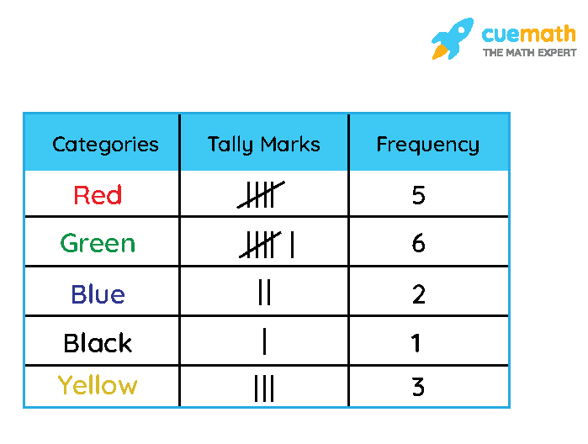

Thus, the table so obtained is called a [frequency distribution table](https://www.cuemath.com/data/frequency-distribution-table/).

**Types of Frequency Distribution Table**

There are two types of frequency distribution tables: Grouped and ungrouped frequency distribution tables.

**Grouped Frequency Distribution Table:**To arrange a large number of observations or data, we use grouped frequency distribution table. In this, we form class intervals to tally the frequency for the data that belongs to that particular class interval.

For example, Marks obtained by 20 students in the test are as follows. 5, 10, 20, 15, 5, 20, 20, 15, 15, 15, 10, 10, 10, 20, 15, 5, 18, 18, 18, 18. To arrange the data in grouped table we have to make class intervals. Thus, we will make class intervals of marks like 0 – 5, 6 – 10, and so on. Given below table shows two columns one is of class intervals (marks obtained in test) and the second is of frequency (no. of students). In this, we have not used tally marks as we counted the marks directly.

| **Marks obtained in Test (class intervals)** | **No. of Students (Frequency)** |
| --- | --- |
| 0 – 5 | 3 |
| 6 – 10 | 4 |
| 11 – 15 | 5 |
| 16 – 20 | 8 |
| Total | 20 |

**Ungrouped Frequency Distribution Table:**In the ungrouped frequency distribution table, we don't make class intervals, we write the accurate frequency of individual data. Considering the above example, the ungrouped table will be like this. Given below table shows two columns: one is of marks obtained in the test and the second is of frequency (no. of students).

| **Marks obtained in Test** | **No. of Students** |
| --- | --- |
| 5 | 3 |
| 10 | 4 |
| 15 | 5 |
| 18 | 4 |
| 20 | 4 |
| Total | 20 |

**Important Notes:**

Following are the important points related to frequency distribution.

* Figures or numbers collected for some definite purpose is called data.
* Frequency is the value in numbers that shows how often a particular item occurs in the given data set.
* There are two types of frequency table - Grouped Frequency Distribution and Ungrouped Frequency Distribution.
* Data can be shown using graphs like histograms, bar graphs, frequency polygons, and so on.

A variable is a measurable characteristic which changes from one member of a sample or a population to another, for example, age of a person, GDP of a country.

A continuous variable is a measurable characteristic which potentially can take any value in a continuous range, without any breaks or jumps.

A discrete variable is a measurable characteristic which is restricted to a specific set of values.

**Discrete data** are often represented by **bar charts,** showing **Continuous data are usually represented as histograms**, showing frequency density per unit of the variable.

Descriptive statistics has great relevance in maths because simply presenting raw data cannot be understood by people. **Descriptive statistics enables people to present the data in a more expressive way**, which allows simpler interpretation of the data.

Descriptive statistics makes use of graphical techniques and numerical descriptive measures to summarize and present the data.

**Tabular Methods**

**Graphical Methods**

There are many types of graphical representation:

1. The Bar Chart: To Construct a Bar Chart, place categories on the horizontal axis, then place frequency (or relative frequency) on the vertical axis. After that construct vertical bars of equal width, one for each category. Its height is proportional to the frequency (or relative frequency) of the category.
2. The Pie Chart: For drawing pie chart, make complete circle that represents the total number of measurements. Partition into slices - one for each category. Then, the size of a slice is proportional to the relative frequency of that category. Determine the angle of each slice by multiplying the relative frequency by 360 degree.

Graphical Methods for Quantitative Data include Stem-and-leaf plot and Histogram.

1. **Stem-and-leaf plot**: Steps for Constructing Stem and Leaf Display are as follows:
   1. Break up each data into two pieces: Stem and leaf. To do this, select one or more leading digits of the data for the stem. The trailing digit or digits become leaves.
   2. List possible stem values in a (vertical) column, with the smallest stem on top.
   3. Record the leaf corresponding to each stem beside it in a row.
   4. Indicate the units for stems and leaves somewhere in the display.
   5. In general, we want the number of stems to be between 5 and 20, if possible.
2. **Histogram**: A histogram is a graphical representation of a frequency (or relative frequency distribution). A histogram displays the shape of the data. It is useful when it is logical to group data into numerical categories.
3. **Quantile plots**: These visually portray the quantiles, or percentiles (which equals to the quantiles times 100) of the distribution of sample data. Quantiles of importance such as the median are easily discerned (quantile, or cumulative frequency = 0.5). Main benefits of Quantile plots are as follows:  
   1. Arbitrary categories are not required, as with histograms or S-L's.
   2. All of the data are displayed, unlike a boxplot.
   3. Every point has a distinct position, without overlap.
4. **Boxplots:** Boxplot is a very useful and brief graphical display for summarizing the distribution of a data set. Boxplots provide visual summaries of the centre of the data (the median-the centre line of the box), the variation or spread (interquartile range-the box height), the skewness (quartile skew-the relative size of box halves) and presence or absence of unusual values ("outside" and "far outside" values). Boxplots are even more useful in comparing these attributes among several data sets.

**Numerical Methods**

These procedures are used to **arithmetically describe data** from a sample or population.

**The numerical measures of a sample** can be used to estimate the corresponding **numerical measures of the population**.

Characteristically, there are two general types of statistic that are used to describe data:  
**Measures of central tendency**: These are ways of describing the central position of a frequency distribution for a group of data. Measures of central tendency are numbers that tend to cluster around the "**middle" of a set of values**. These include the **mode, median, and mean.**

Mean is the average value, calculated by adding all the observations and dividing by the number of observations. A drawback of the mean is that it is **heavily influenced by extreme observations.**

**The median is explained as the middle value** when observations are arranged in an ascending or descending order. The median is easy to understand, and **it is not greatly affected by extreme observations.**

The mode is described as the **most common value of individually recorded observations** and as the value of the variable for which the frequency density is greatest for grouped data.

Measures of spread: In this type of statistic, group of data is summarized by describing how spread out the scores are. To describe this spread, a number of statistics are available such as the range, quartiles, absolute deviation, variance and standard deviation. When descriptive statistics is used, it is useful to summarize group of data using a combination of tabulated description, graphical description such as graphs and charts and statistical commentary such as discussion of the results.

To summarize, Descriptive statistics consists of statistical procedures that are used to describe the population that are studying. The data could be collected from either a sample or a population, but the results help statistician organize and describe data. Descriptive statistics can only be used to describe the group that is being studying. That is, the results cannot be generalized to any larger group. There are three methods of descriptive statistics that include tabular, graphical and numerical methods.

**Central Tendency**

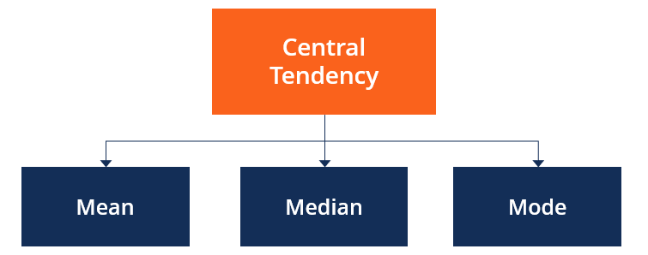

Central tendency refers to a **dataset’s descriptive summary** using a single value reflecting the center of the data distribution.

Measures of central tendency are also known as **measures of central location.**

The mean, [median](https://corporatefinanceinstitute.com/resources/knowledge/other/median/), and mode are the measures of central tendency.

The mean, considered the most popular measure of central tendency, is the average or most common value in a data set.

The median refers to the middle score for a data set in ascending order.

The mode refers to the score or value that is most frequent in a data set.

**Measures of Central Tendency**

**Mean:** The [mean](https://www.cuemath.com/data/mean/) can be defined as the sum of all observations divided by the The most commonly used measure of central tendency is **the mean**.

Mean = (sum of all values) / (total # of values)

For example, suppose we have the following dataset that shows the number of home runs hit by 10 baseball players on the same team in one season:

|  |  |  |  |  |  |  |  |  |  |  |
| --- | --- | --- | --- | --- | --- | --- | --- | --- | --- | --- |
| **Player** | **#1** | **#2** | **#3** | **#4** | **#5** | **#6** | **#7** | **#8** | **#9** | **#10** |
| **Home Runs** | 8 | 15 | 22 | 21 | 12 | 9 | 11 | 27 | 14 | 13 |

The mean number of home runs hit per player can be calculated as:

Mean  = (8+15+22+21+12+9+11+27+14+13) / 10 = **15.2 home runs**.

total number of observations. The formulas for the mean are given as follows

**Median:**The **median** is the middle value in a dataset. You can find the median by arranging all the individual values in a dataset from smallest to largest and finding the middle value. If there are an odd number of values, the median is the middle value. If there are an even number of values, the median is the average of the two middle values.

For example, to find the median number of home runs hit by the 10 baseball players in the previous example we can arrange the players in order from least to greatest number of home runs hit:

|  |  |  |  |  |  |  |  |  |  |  |
| --- | --- | --- | --- | --- | --- | --- | --- | --- | --- | --- |
| **Player** | **#1** | **#6** | **#7** | **#5** | **#10** | **#9** | **#2** | **#4** | **#3** | **#8** |
| **Home Runs** | 8 | 9 | 11 | 12 | **13** | **14** | 15 | 21 | 22 | 27 |

Since we have an even number of values, the median is simply the average of the two middle values: **13.5**.

Instead, consider if we had nine players:

|  |  |  |  |  |  |  |  |  |  |
| --- | --- | --- | --- | --- | --- | --- | --- | --- | --- |
| **Player** | **#1** | **#6** | **#7** | **#5** | **#9** | **#2** | **#4** | **#3** | **#8** |
| **Home Runs** | 8 | 9 | 11 | 12 | **14** | 15 | 21 | 22 | 27 |

In this case, since we have an odd number of values the median is simply the middle value: **14**.

**Mode:**The **mode** is the value that occurs most often in a dataset. A dataset can have no mode (if no value repeats), one mode, or multiple modes.

For example, the following dataset has no mode:

|  |  |  |  |  |  |  |  |  |  |  |
| --- | --- | --- | --- | --- | --- | --- | --- | --- | --- | --- |
| **Player** | **#1** | **#2** | **#3** | **#4** | **#5** | **#6** | **#7** | **#8** | **#9** | **#10** |
| **Home Runs** | 8 | 9 | 11 | 12 | 13 | 14 | 15 | 21 | 22 | 27 |

The following dataset has one mode: **15**. This is the value that occurs most frequently.

|  |  |  |  |  |  |  |  |  |  |  |
| --- | --- | --- | --- | --- | --- | --- | --- | --- | --- | --- |
| **Player** | **#1** | **#2** | **#3** | **#4** | **#5** | **#6** | **#7** | **#8** | **#9** | **#10** |
| **Home Runs** | 8 | 9 | 11 | 12 | 13 | **15** | **15** | 21 | 22 | 27 |

The following dataset has three modes: **8, 15, 19**. These are the values that occur most frequently.

|  |  |  |  |  |  |  |  |  |  |  |
| --- | --- | --- | --- | --- | --- | --- | --- | --- | --- | --- |
| **Player** | **#1** | **#2** | **#3** | **#4** | **#5** | **#6** | **#7** | **#8** | **#9** | **#10** |
| **Home Runs** | **8** | **8** | 11 | 12 | **15** | **15** | 17 | **19** | **19** | 27 |

The mode can be a particularly helpful measure of central tendency when working with categorical data because it tells us which category occurs most frequently. For example, consider the following bar chart that shows the results of a survey about people’s favorite color:

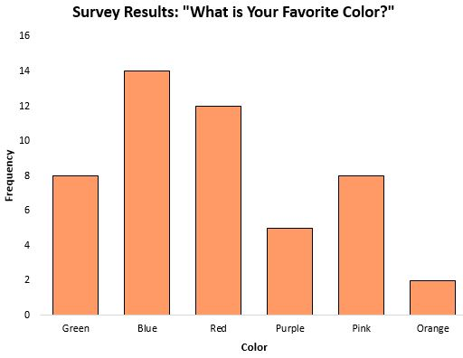

The **mode**, or the response that occurred most frequently, was blue.

In scenarios where the data is categorical (like the one above), it’s not even possible to calculate the median or the mean, so the mode is the only measure of central tendency we can use.

The mode can also be used for numerical data, like we saw in the above example with baseball players. However, the mode tends to be less helpful at answering the question *“What’s a typical value for this dataset?”*

For example, suppose we want to know the typical number of home runs hit by a baseball player on this team:

|  |  |  |  |  |  |  |  |  |  |  |
| --- | --- | --- | --- | --- | --- | --- | --- | --- | --- | --- |
| **Player** | **#1** | **#2** | **#3** | **#4** | **#5** | **#6** | **#7** | **#8** | **#9** | **#10** |
| **Home Runs** | 8 | 8 | 11 | 12 | 15 | 15 | 17 | 19 | 19 | 27 |

The mode of this dataset is 8, 15, and 19, since these are the values that occur most frequently. However, these aren’t terribly helpful for understanding the typical number of home runs hit by a player on the team. A better measure of central tendency would be the median (15) or the mean (also 15) in this case.

The mode is also a poor measure of central tendency when it happens to be a number that is far away from the rest of the values. For example, the mode of the following dataset is 30, but this doesn’t actually represent the “typical” number of home runs hit per player on the team:

|  |  |  |  |  |  |  |  |  |  |  |
| --- | --- | --- | --- | --- | --- | --- | --- | --- | --- | --- |
| **Player** | **#1** | **#2** | **#3** | **#4** | **#5** | **#6** | **#7** | **#8** | **#9** | **#10** |
| **Home Runs** | 5 | 6 | 7 | 10 | 11 | 12 | 13 | 15 | 30 | 30 |

Once again, the mean or median would do a better job of describing the center location of this dataset.

**When to Use the Mean, Median, and Mode**

**When to use the mean**

It is best to use the mean when the distribution of the data is **fairly symmetrical** and there are no outliers.

For example, suppose we have the following distribution that shows the salaries of individuals in a certain town:

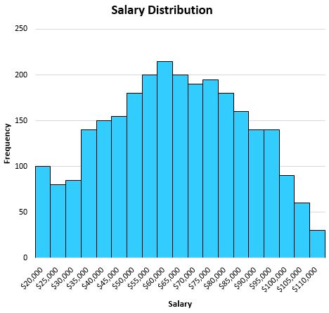

Since this distribution is fairly symmetrical (i.e. if you split it down the middle, each half would look roughly equal) and there are no outliers (i.e. no extremely high salaries), the mean will do a good job of describing this dataset.

The mean turns out to be $63,000, which is roughly located in the center of the distribution:

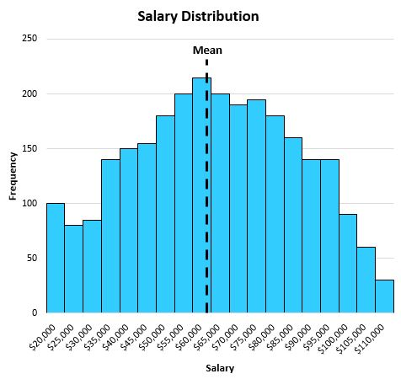

**When to use the median**

It is best to use the median when the distribution of the data is either skewed or there are outliers present.

**Skewed data:**

When the distribution is skewed, the median still does a good job of capturing the center location. For example, consider the following distribution of salaries for individuals in a certain town:

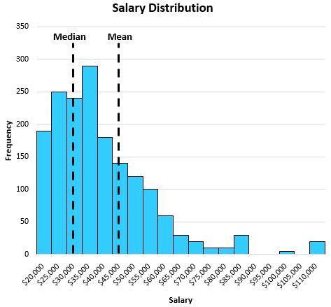

The median does a better job of capturing the “typical” salary of an individual than the mean. This is because the large values on the tail end of a distribution tend to pull the mean away from the center and towards the long tail.

In this particular example, the mean tells us that the typical individual earns about $47,000 per year in this town while the median tells us that the typical individual only earns about $32,000 per year, which is much more representative of the typical individual.

**Outliers:**

**The median also does a better job of capturing the central location of a distribution when there are outliers present in the data.** For example, consider the following chart that shows the square footage of houses on a certain street:

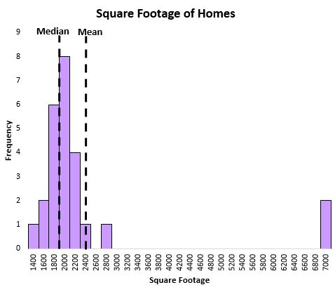

The mean is heavily influenced by a couple extremely large houses, while the median is not. Thus, the median does a better job of capturing the “typical” square footage of a house on this street compared to the mean.

**When to use the mode**

It is best to use the mode **when you are working with categorical data** and you want to know which category occurs most frequently. Here are a couple examples:

* You conduct a survey about people’s favorite colors and you want to know which color occurs most frequently in the responses.
* You conduct a survey about people’s preferences among three choices for a website design and you want to know which design people prefer most.

As mentioned earlier, if you’re working with categorical data then it’s not even possible to calculate the median or mean, which leaves the mode as the only measure of central tendency.

In general, if you’re working with numerical data like square footage of homes, number of home runs hit per player, salary per individual, etc. then it’s usually better to use the median or the mean to describe the “typical” value in the dataset.

**Note:**It’s important to note that if a dataset is *perfectly*normally distributed, then the mean, median, and mode are all the same value.

**Case 1: Symmetric distribution**

Consider a symmetric distribution. Assume the monthly salary of employees in an organization as 30k, 40k, 35k, 32k, 38k rupees.

Mean = (30 + 40 + 35 + 32 + 38)/5 = 175/5 = 35k rupees

Median: Sort the data in ascending order. 30k, 32k, 35k, 38k, 40k. Since the middlemost value in the sorted dataset is 35k. We can conclude that median salary = 35k rupees. No clear mode as all the data value occurs the same number of times.

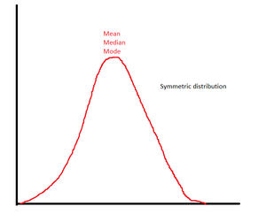

*Mean = Median = mode in symmetric distribution*

**Case 2: Skewed distribution**

In skewed distribution where one value is exceptionally different from other values, the mean value changes drastically.

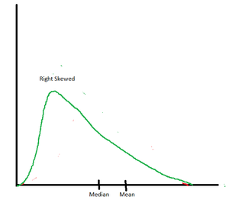

*Mean > median in right skew distribution*

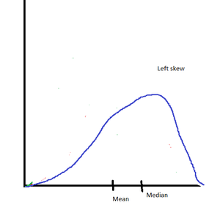

*Mean < median in left-skewed distribution*

Let us assume a scenario where an employee is promoted, and he gets an awesome hike in salary. Assume that his salary changes from 38k per month to 85k per month. This is a case of right skew as the data value has been shifted towards the right. According to the figure, we expect that mean should be more than the median.

Let us compute the new values of mean & median

New dataset has values 30, 40, 35, 32, 88

Mean = (30 + 40 + 35 + 32 + 88) = 225/5 = 45k rupees

Median:

Sort the data in ascending order.

30k, 32k, 35k, 40k,88k

Since the middlemost value in the sorted dataset is 35k, we can conclude that median salary = 35k rupees. Thus, we saw that the mean value changed, but the median value is still 35k rupees. It is evident that the mean value is extremely sensitive to changes in data. However, the median is relatively stable.

**The Best Measure of Central Tendency**

* Mean is the preferred measure of central tendency when data is normally distributed.
* Median is the best measure of central tendency when data is skewed.
* While dealing with nominal variables, the model is the best measure of central tendency.

**Conclusion**

* Mean, median, and mode are the most important measures of central tendency. The complete dataset may be represented by these values.
* It is not necessary for mean, median, and mode to have the same values.
* **Mean is sensitive to extreme data values**.
* It is not wise to take the mean of skewed distribution as the true representative of the dataset.
* Median is a better way to understand skewed distribution.
* Mean and median can not be zero unless all data values are zero. However, it is possible that there is no mode in the dataset.

**Variability** describes how far apart data points lie from each other and from the center of a distribution. Along with measures of [central tendency](https://www.scribbr.com/statistics/central-tendency/), measures of variability give you [descriptive statistics](https://www.scribbr.com/statistics/descriptive-statistics/) that summarize your data.

Variability is also referred to as spread, scatter or dispersion. It is most commonly measured with the following:

* [**Range**](https://www.scribbr.com/statistics/range/)**:** the difference between the highest and lowest values
* [**Interquartile range**](https://www.scribbr.com/statistics/interquartile-range/)**:** the range of the middle half of a distribution
* [**Standard deviation**](https://www.scribbr.com/statistics/standard-deviation/)**:** average distance from the mean
* [**Variance**](https://www.scribbr.com/statistics/variance/)**:** average of squared distances from the mean

**Table of contents**

**Why does variability matter?**

While the [central tendency](https://www.scribbr.com/statistics/central-tendency/), or **average, tells you where most of your points lie,**

variability summarizes how far apart they are. This is important because the amount of variability determines how well you can generalize results from the sample to your population.

Low variability is ideal because it means that you can better predict information about the[population](https://www.scribbr.com/methodology/population-vs-sample/) based on sample data. **High variability means that the values are less consistent,** so it’s harder to make predictions.

Data sets can have the same central tendency but different levels of variability or vice versa. If you know only the central tendency or the variability, you can’t say anything about the other aspect. Both of them together give you a complete picture of your data.

Example: Variability in normal distributionsYou are investigating the amounts of time spent on phones daily by different groups of people.

Using [simple random samples](https://www.scribbr.com/methodology/simple-random-sampling/), you collect data from 3 groups:

* Sample A: high school students,
* Sample B: college students,
* Sample C: adult full-time employees.

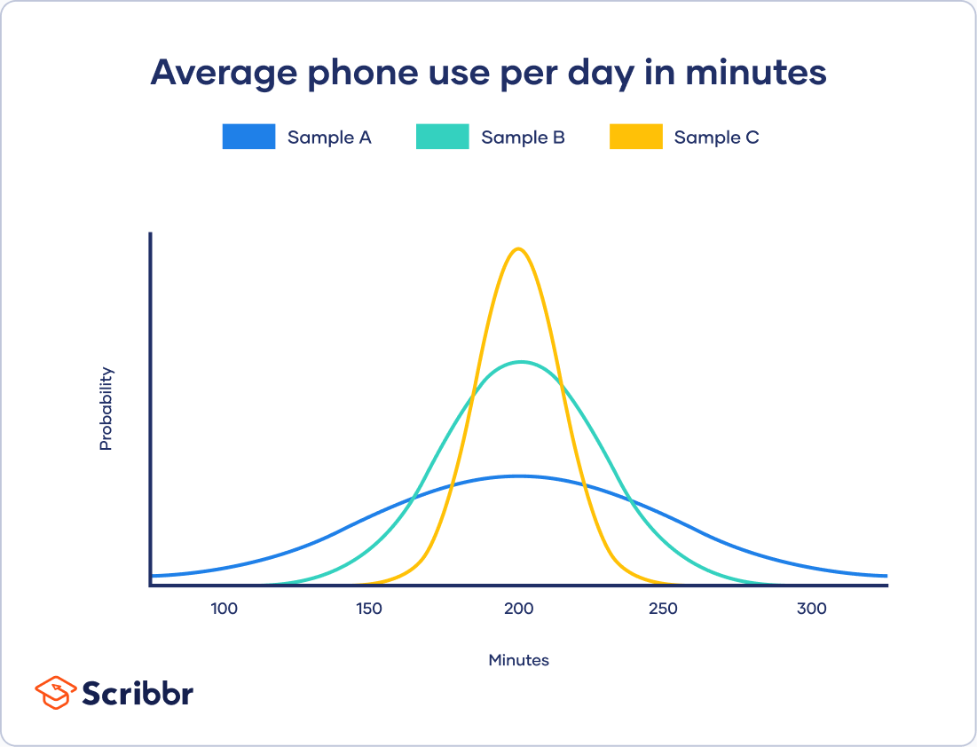

All three of your samples have the same average phone use, at 195 minutes or 3 hours and 15 minutes. This is the x-axis value where the peak of the curves are.

Although the data follows a [normal distribution](https://www.scribbr.com/statistics/normal-distribution/), each sample has different spreads. Sample A has the largest variability while Sample C has the smallest variability.

**Range**

The range tells you the spread of your data from the lowest to the highest value in the distribution. It’s the easiest measure of variability to calculate.

To [find the range](https://www.scribbr.com/statistics/range/), simply subtract the lowest value from the highest value in the data set.

Range exampleYou have 8 data points from Sample A.

|  |  |  |  |  |  |  |  |  |
| --- | --- | --- | --- | --- | --- | --- | --- | --- |
| **Data (minutes)** | 72 | 110 | 134 | 190 | 238 | 287 | 305 | 324 |

The highest value (*H*) is **324** and the lowest (*L*) is **72**.

*R* = *H* – *L*

*R*= 324 – 72 = **252**

The range of your data is **252 minutes**.

Because only 2 numbers are used, the range is influenced by [outliers](https://www.scribbr.com/statistics/outliers/) and doesn’t give you any information about the distribution of values. It’s best used in combination with other measures.

**Here's why students love Scribbr's proofreading services**

[**Discover proofreading & editing**](https://www.scribbr.com/proofreading-editing/paper-editing-service/?scr_source=knowledgebase&scr_medium=in-text&scr_campaign=proofreading&src_content=trustpilot)

**Interquartile range**

The[interquartile range](https://www.scribbr.com/statistics/interquartile-range/) gives you the spread of the middle of your distribution.

For any distribution that’s ordered from low to high, the interquartile range contains half of the values. While the first [quartile](https://www.scribbr.com/statistics/quartiles-quantiles/) (Q1) contains the first 25% of values, the fourth quartile (Q4) contains the last 25% of values.

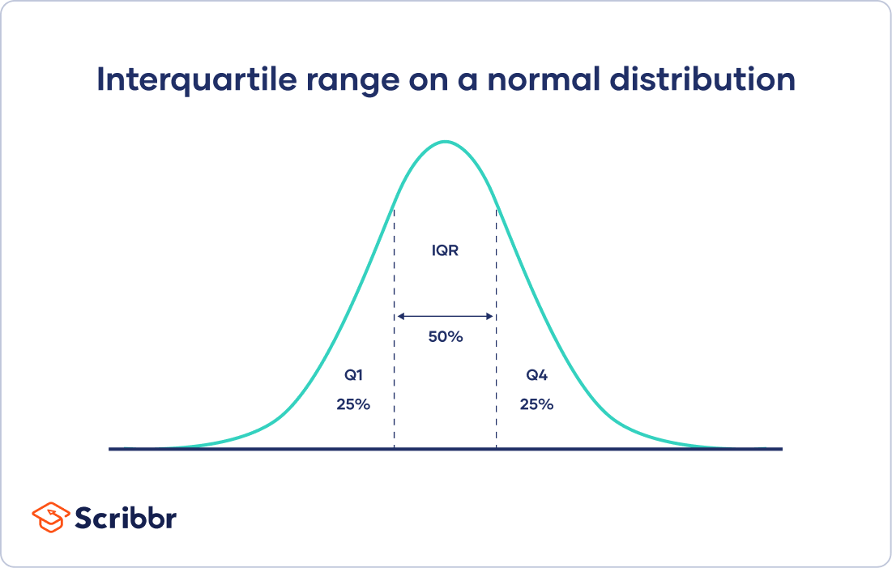

The interquartile range is the third quartile (Q3) minus the first quartile (Q1). This gives us the range of the middle half of a data set.

Interquartile range exampleTo find the interquartile range of your 8 data points, you first find the values at Q1 and Q3.

Multiply the number of values in the data set (8) by 0.25 for the 25th percentile (Q1) and by 0.75 for the 75th percentile (Q3).

Q1 position: 0.25 x 8 = 2

Q3 position: 0.75 x 8 = 6

Q1 is the value in the 2nd position, which is **110**. Q3 is the value in the 6th position, which is **287**.

IQR = Q3 – Q1

IQR = 287 – 110 = **177**

The interquartile range of your data is **177 minutes**.

Just like the range, the interquartile range uses only 2 values in its calculation. But the IQR is less affected by outliers: the 2 values come from the middle half of the data set, so they are unlikely to be extreme scores.

The IQR gives a consistent measure of variability for skewed as well as normal distributions.

**Five-number summary**

Every distribution can be organized using a**five-number summary**:

* Lowest value
* Q1: 25th percentile
* Q2: the median
* Q3: 75th percentile
* Highest value (Q4)

These five-number summaries can be easily visualized using box and whisker plots.

Box and whisker plot exampleFor each of our samples, the horizontal lines in a box show Q1, the median and Q3, while the whiskers at the end show the highest and lowest values.

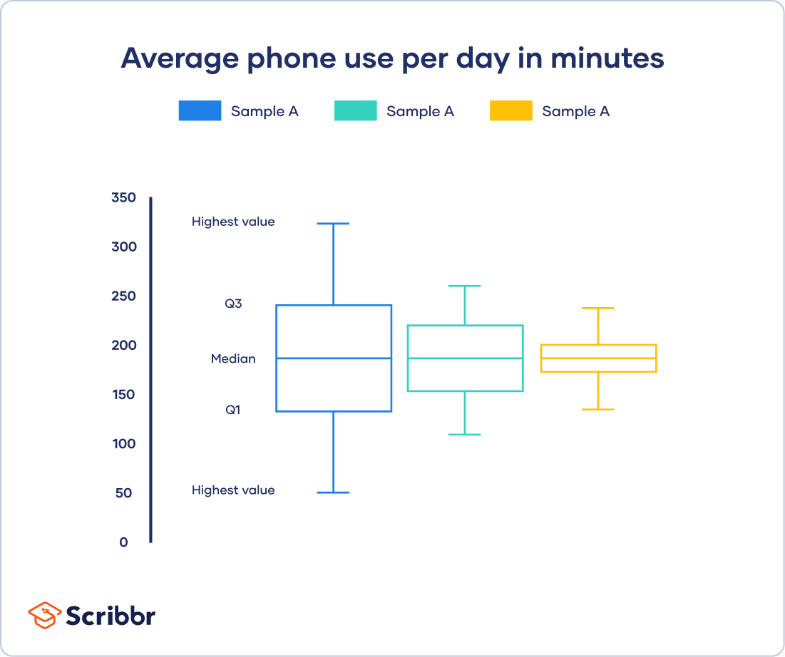

**Standard deviation**

The [standard deviation](https://www.scribbr.com/statistics/standard-deviation/)is the average amount of variability in your dataset.

It tells you, on average, how far each score lies from the mean. The larger the standard deviation, the more variable the data set is.

There are six steps for finding the standard deviation by hand:

1. List each score and [find their mean](https://www.scribbr.com/statistics/mean/).
2. Subtract the mean from each score to get the deviation from the mean.
3. Square each of these deviations.
4. Add up all of the squared deviations.
5. Divide the sum of the squared deviations by *n* – 1 (for a[sample](https://www.scribbr.com/methodology/population-vs-sample/)) or *N* (for a population).
6. Find the square root of the number you found.

* [**Steps 1–4**](https://www.scribbr.com/statistics/variability/)

* [**Step 5**](https://www.scribbr.com/statistics/variability/)

* [**Step 6**](https://www.scribbr.com/statistics/variability/)

Standard deviation example

| **Step 1: Data (minutes)** | **Step 2: Deviation from mean** | **Steps 3 + 4: Squared deviation** |
| --- | --- | --- |
| **72** | 72 – 207.5 = -135.5 | 18360.25 |
| **110** | 110 – 207.5 = -97.5 | 9506.25 |
| **134** | 134 – 207.5 = -73.5 | 5402.25 |
| **190** | 190 – 207.5 = -17.5 | 306.25 |
| **238** | 238 – 207.5 = 30.5 | 930.25 |
| **287** | 287 – 207.5 = 79.5 | 6320.25 |
| **305** | 305 – 207.5 = 97.5 | 9506.25 |
| **324** | 324 – 207.5 = 116.5 | 13572.25 |
| Mean = **207.5** | Sum = 0 | Sum of squares =**63904** |

**Standard deviation formula for populations**

If you have data from the entire population, use the population standard deviation formula:

| **Formula** | **Explanation** |
| --- | --- |
| Formula to find the standard deviation of a population | * σ = population standard deviation * ∑ = sum of… * *X* = each value * μ = population mean * *N* = number of values in the population |

**Standard deviation formula for samples**

If you have data from a sample, use the sample standard deviation formula:

| **Formula** | **Explanation** |
| --- | --- |
| Formula to find the standard deviation of a sample. | * *s* = sample standard deviation * ∑ = sum of… * *X* = each value * x̅ = sample mean * *n* = number of values in the sample |

**Why use *n* – 1 for sample standard deviation?**

[Samples](https://www.scribbr.com/methodology/population-vs-sample/) are used to make [statistical inferences](https://www.scribbr.com/statistics/inferential-statistics/) about the population that they came from.

When **you have population data**, you can get an exact value for population standard deviation. **Since you collect data from every population member**, the standard deviation reflects the precise amount of variability in your distribution, the population.

But **when you use sample data,** your **sample standard deviation is always used as an estimate of the population standard deviation**. Using ***n* in this formula tends to give you a biased estimate that consistently underestimates variability**.

Reducing the sample ***n* to *n* – 1 makes the standard deviation artificially large**, giving you a conservative estimate of variability.

While this is not an unbiased estimate, it is a less biased estimate of standard deviation: **it is better to overestimate rather than underestimate variability in samples.**

The difference between biased and conservative estimates of standard deviation gets much smaller when you have a large sample size.

**Variance**

**The**[**variance**](https://www.scribbr.com/statistics/variance/)**is the average of squared deviations from the mean**. A deviation from the mean is how far a score lies from the mean.

Variance is the square of the standard deviation. This means that the units of variance are much larger than those of a typical value of a data set.

While it’s harder to interpret the variance number intuitively, it’s important to calculate variance for comparing different data sets in statistical tests like [ANOVAs](https://www.scribbr.com/statistics/one-way-anova/).

Variance reflects the **degree of spread in the data set**. The more spread the data, the larger the variance is in relation to the mean.

Variance exampleTo get variance, square the standard deviation.

*s* = 95.5

*s*2= 95.5 x 95.5 = 9129.14

The variance of your data is 9129.14.

To find the variance by hand, perform all of the steps for standard deviation except for the final step.

**Variance formula for populations**

| **Formula** | **Explanation** |
| --- | --- |
| Variance formula for populations | * σ2 = population variance * Σ = sum of… * *Χ*= each value * μ = population mean * *Ν* = number of values in the population |

**Variance formula for samples**

| **Formula** | **Explanation** |
| --- | --- |
| Variance formula for samples | * *s2* = sample variance * Σ = sum of… * *Χ*= each value * x̄ = sample mean * *n* = number of values in the sample |

**Biased versus unbiased estimates of variance**

An unbiased estimate in statistics is one **that doesn’t consistently give you either high values or low values** – it has no systematic bias.

Just like for standard deviation, there are different formulas for population and sample variance. But while there is no unbiased estimate for standard deviation, there is one for sample variance.

If the sample variance formula used the sample *n*, the sample variance would be biased towards lower numbers than expected. Reducing the sample *n* to *n* – 1 makes the variance artificially larger.

In this case, bias is not only lowered but totally removed. The sample variance formula gives completely unbiased estimates of variance.

So why isn’t the sample standard deviation also an unbiased estimate?

That’s because sample standard deviation comes from finding the square root of sample variance. Since a square root isn’t a linear operation, like addition or subtraction, the unbiasedness of the sample variance formula isn’t carried over the sample standard deviation formula.

**What’s the best measure of variability?**

The best measure of variability depends on your [level of measurement](https://www.scribbr.com/statistics/levels-of-measurement/) and distribution.

**Level of measurement**

For data measured at an [ordinal](https://www.scribbr.com/statistics/ordinal-data/) level, **the range and interquartile** range are the only appropriate measures of variability.

Ordinal – range, IQR

For more complex [interval](https://www.scribbr.com/statistics/interval-data/) and [ratio](https://www.scribbr.com/statistics/ratio-data/) levels, the **standard deviation and variance** are also applicable.

**Distribution**

For normal distributions, all measures can be used. The standard deviation and variance are preferred because they take your whole data set into account, but this also means that they are easily influenced by outliers.

For skewed distributions or data sets with outliers, the interquartile range is the best measure. It’s least affected by extreme values because it focuses on the spread in the middle of the data set.

**Frequently asked questions about variability**

[What is variability?](https://www.scribbr.com/frequently-asked-questions/what-is-variability/)

[What are the 4 main measures of variability?](https://www.scribbr.com/frequently-asked-questions/what-are-the-4-main-measures-of-variability/)

[**What’s the difference between central tendency and variability?**](https://www.scribbr.com/frequently-asked-questions/central-tendency-vs-variability/)

While[central tendency](https://www.scribbr.com/statistics/central-tendency/) tells you where most of your data points lie, [variability](https://www.scribbr.com/statistics/variability/) summarizes how far apart your points from each other.

Data sets can have the same central tendency but different levels of variability or vice versa. Together, they give you a complete picture of your data.

[Variability](https://www.scribbr.com/statistics/variability/) tells you how far apart points lie from each other and from the center of a distribution or a data set.

Variability is also referred to as spread, scatter or dispersion.

Descriptive statistics summarize the characteristics of a data set. Inferential statistics allow you to test a hypothesis or assess whether your data is generalizable to the broader population.

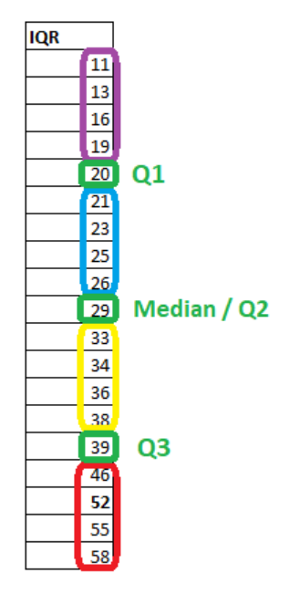

**Normal Distribution:**

In probability theory and statistics, the **Normal Distribution**, also called the **Gaussian Distribution**, is the most significant **continuous probability distribution**. Sometimes it is also called a **bell curve**. A large number of random variables are **either nearly or exactly represented by the normal distribution**,

Normal Distribution Definition

The Normal Distribution is defined by the[**probability density function**](https://byjus.com/maths/probability-density-function/) for a **continuous random variable** in a system.

Let us say, **f(x) is the probability density function** and **X is the random variable**. Hence, it defines a function which is **integrated between the range or interval (x to x + dx**), giving **the probability of random variable X,** by considering the **values between x and x+dx.**

f(x) ≥ 0 ∀ x ϵ (−∞,+∞)

And -∞∫+∞ f(x) = 1

Normal Distribution Formula

The probability density function of normal or gaussian distribution is given by;

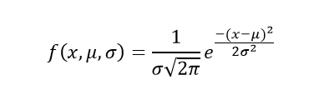

Where,

* x is the variable
* μ is the mean
* σ is the standard deviation

The [random variables](https://byjus.com/maths/random-variable/) following the **normal distribution are those whose values can find any unknown value in a given range**. For example, finding the height of the students in the school. Here, the distribution can consider any value, but it will be bounded in the range say, **0 to 6ft.** This limitation is forced physically in our query.

Whereas, the **normal distribution doesn’t even bother about the range**. The range can also extend to **–∞ to + ∞** and **still we can find a smooth curve**. These random variables are called **Continuous Variables,** and the Normal Distribution then provides here probability of the value lying in a particular range for a given experiment. Also, use the [normal distribution calculator](https://byjus.com/normal-distribution-calculator/) to find the probability density function by just providing the mean and standard deviation value.

Normal Distribution Standard Deviation

Generally, the normal distribution has **any positive standard deviation**. We know that the mean helps to determine the line of **symmetry of a graph**, whereas the **standard deviation** helps to know how far the data are **spread out.** If the **standard deviation is smaller,** the data are somewhat close to each other and **the graph becomes narrower**. If **the standard deviation is larger**, the data are dispersed more, and **the graph becomes wider.** The **standard deviations are used to subdivide the area under the normal curve**. Each **subdivided section defines the percentage of data**, which falls into the specific region of a graph.

Using 1 standard deviation, the Empirical Rule states that,

* **Approximately 68% of the data falls within one standard deviation of the mean.** (i.e., Between Mean- one Standard Deviation and Mean + one standard deviation)
* **Approximately 95% of the data falls within two standard deviations of the mean. (i.e., Between Mean- two Standard Deviation and Mean + two standard deviations)**
* Approximately 99.7% of the data fall within three standard deviations of the mean. (i.e., Between Mean- three Standard Deviation and Mean + three standard deviations)

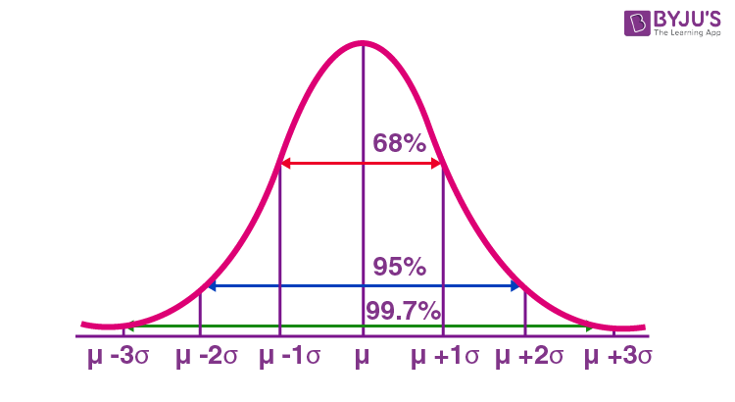

Thus, the empirical rule is also called the 68 – 95 – 99.7 rule.

Normal Distribution Table

The table here shows the area from 0 to Z-value.

|  |  |  |  |  |  |  |  |  |  |  |
| --- | --- | --- | --- | --- | --- | --- | --- | --- | --- | --- |
| **Z-Value** | **0.00** | **0.01** | **0.02** | **0.03** | **0.04** | **0.05** | **0.06** | **0.07** | **0.08** | **0.09** |
| 0.0 | 0.0000 | 0.0040 | 0.0080 | 0.0120 | 0.0160 | 0.0199 | 0.0239 | 0.0279 | 0.0319 | 0.0359 |
| 0.1 | 0.0398 | 0.0438 | 0.0478 | 0.0517 | 0.0557 | 0.0596 | 0.0636 | 0.0675 | 0.0714 | 0.0753 |
| 0.2 | 0.0793 | 0.0832 | 0.0871 | 0.0910 | 0.0948 | 0.0987 | 0.1026 | 0.1064 | 0.1103 | 0.1141 |
| 0.3 | 0.1179 | 0.1217 | 0.1255 | 0.1293 | 0.1331 | 0.1368 | 0.1406 | 0.1443 | 0.1480 | 0.1517 |
| 0.4 | 0.1554 | 0.1591 | 0.1628 | 0.1664 | 0.1700 | 0.1736 | 0.1772 | 0.1808 | 0.1844 | 0.1879 |
| 0.5 | 0.1915 | 0.1950 | 0.1985 | 0.2019 | 0.2054 | 0.2088 | 0.2123 | 0.2157 | 0.2190 | 0.2224 |
| 0.6 | 0.2257 | 0.2291 | 0.2324 | 0.2357 | 0.2389 | 0.2422 | 0.2454 | 0.2486 | 0.2517 | 0.2549 |
| 0.7 | 0.2580 | 0.2611 | 0.2642 | 0.2673 | 0.2704 | 0.2734 | 0.2764 | 0.2794 | 0.2823 | 0.2852 |
| 0.8 | 0.2881 | 0.2910 | 0.2939 | 0.2967 | 0.2995 | 0.3023 | 0.3051 | 0.3078 | 0.3106 | 0.3133 |
| 0.9 | 0.3159 | 0.3186 | 0.3212 | 0.3238 | 0.3264 | 0.3289 | 0.3315 | 0.3340 | 0.3365 | 0.3389 |
| 1.0 | 0.3413 | 0.3438 | 0.3461 | 0.3485 | 0.3508 | 0.3531 | 0.3554 | 0.3577 | 0.3599 | 0.3621 |
| 1.1 | 0.3643 | 0.3665 | 0.3686 | 0.3708 | 0.3729 | 0.3749 | 0.3770 | 0.3790 | 0.3810 | 0.3830 |
| 1.2 | 0.3849 | 0.3869 | 0.3888 | 0.3907 | 0.3925 | 0.3944 | 0.3962 | 0.3980 | 0.3997 | 0.4015 |
| 1.3 | 0.4032 | 0.4049 | 0.4066 | 0.4082 | 0.4099 | 0.4115 | 0.4131 | 0.4147 | 0.4162 | 0.4177 |
| 1.4 | 0.4192 | 0.4207 | 0.4222 | 0.4236 | 0.4251 | 0.4265 | 0.4279 | 0.4292 | 0.4306 | 0.4319 |
| 1.5 | 0.4332 | 0.4345 | 0.4357 | 0.4370 | 0.4382 | 0.4394 | 0.4406 | 0.4418 | 0.4429 | 0.4441 |
| 1.6 | 0.4452 | 0.4463 | 0.4474 | 0.4484 | 0.4495 | 0.4505 | 0.4515 | 0.4525 | 0.4535 | 0.4545 |
| 1.7 | 0.4554 | 0.4564 | 0.4573 | 0.4582 | 0.4591 | 0.4599 | 0.4608 | 0.4616 | 0.4625 | 0.4633 |
| 1.8 | 0.4641 | 0.4649 | 0.4656 | 0.4664 | 0.4671 | 0.4678 | 0.4686 | 0.4693 | 0.4699 | 0.4706 |
| 1.9 | 0.4713 | 0.4719 | 0.4726 | 0.4732 | 0.4738 | 0.4744 | 0.4750 | 0.4756 | 0.4761 | 0.4767 |
| 2.0 | 0.4772 | 0.4778 | 0.4783 | 0.4788 | 0.4793 | 0.4798 | 0.4803 | 0.4808 | 0.4812 | 0.4817 |
| 2.1 | 0.4821 | 0.4826 | 0.4830 | 0.4834 | 0.4838 | 0.4842 | 0.4846 | 0.4850 | 0.4854 | 0.4857 |
| 2.2 | 0.4861 | 0.4864 | 0.4868 | 0.4871 | 0.4875 | 0.4878 | 0.4881 | 0.4884 | 0.4887 | 0.4890 |
| 2.3 | 0.4893 | 0.4896 | 0.4898 | 0.4901 | 0.4904 | 0.4906 | 0.4909 | 0.4911 | 0.4913 | 0.4916 |
| 2.4 | 0.4918 | 0.4920 | 0.4922 | 0.4925 | 0.4927 | 0.4929 | 0.4931 | 0.4932 | 0.4934 | 0.4936 |
| 2.5 | 0.4938 | 0.4940 | 0.4941 | 0.4943 | 0.4945 | 0.4946 | 0.4948 | 0.4949 | 0.4951 | 0.4952 |
| 2.6 | 0.4953 | 0.4955 | 0.4956 | 0.4957 | 0.4959 | 0.4960 | 0.4961 | 0.4962 | 0.4963 | 0.4964 |
| 2.7 | 0.4965 | 0.4966 | 0.4967 | 0.4968 | 0.4969 | 0.4970 | 0.4971 | 0.4972 | 0.4973 | 0.4974 |
| 2.8 | 0.4974 | 0.4975 | 0.4976 | 0.4977 | 0.4977 | 0.4978 | 0.4979 | 0.4979 | 0.4980 | 0.4981 |
| 2.9 | 0.4981 | 0.4982 | 0.4982 | 0.4983 | 0.4984 | 0.4984 | 0.4985 | 0.4985 | 0.4986 | 0.4986 |
| 3.0 | 0.4987 | 0.4987 | 0.4987 | 0.4988 | 0.4988 | 0.4989 | 0.4989 | 0.4989 | 0.4990 | 0.4990 |

Normal Distribution Problems and Solutions

**Question 1: Calculate the probability density function of normal distribution using the following data. x = 3, μ = 4 and σ = 2.**

Solution: Given, variable, x = 3

Mean = 4 and

Standard deviation = 2

By the formula of the probability density of normal distribution, we can write;

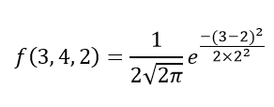

Hence, f(3,4,2) = 1.106.

**Question 2: If the value of random variable is 2, mean is 5 and the standard deviation is 4, then find the probability density function of the gaussian distribution.**

Solution: Given,

Variable, x = 2

Mean = 5 and

Standard deviation = 4

By the formula of the probability density of normal distribution, we can write;

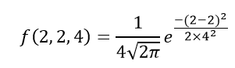

f(2,2,4) = 1/(4√2π) e0

f(2,2,4) = 0.0997

There are two main parameters of normal distribution in statistics namely mean and standard deviation. The location and scale parameters of the given normal distribution can be estimated using these two parameters. 

Normal Distribution Properties

Some of the important properties of the normal distribution are listed below:

* In a normal distribution, **the mean, median and mode are equal**.(i.e., Mean = Median= Mode).
* The **total area under the curve should be equal to 1.**
* The normally distributed curve should be **symmetric at the centre.**
* There should **be exactly half of the values are to the right of the centre and exactly half of the values are to the left of the centre.**
* **The normal distribution should be defined by the mean and standard deviation.**
* **The normal distribution curve must have only one peak. (i.e., Unimodal**)
* The **curve approaches the x-axis, but it never touches**, and it extends farther away from the mean.

Applications

The normal distributions are closely associated with many things such as:

* Marks scored on the test
* Heights of different persons
* Size of objects produced by the machine
* Blood pressure and so on.

Frequently Asked Questions on Normal Distribution – FAQs

What is a normal distribution in statistics?

**A probability function** that specifies how the values of a **variable are distributed is called the normal distribution**. It is symmetric since most of the observations assemble around the central peak of the curve. The probabilities for values of the distribution are distant from the mean narrow off evenly in both directions.

What does normal distribution mean?

In statistics (and in probability theory), the Normal Distribution, also called the Gaussian Distribution, is the most important continuous probability distribution. Sometimes it is also called a bell curve.

What is a normal distribution used for?

A normal distribution is significant in statistics and is often used in the natural sciences and social arts to describe real-valued random variables whose distributions are unknown.

What are the characteristics of a normal distribution?

The essential characteristics of a normal distribution are:  
It is symmetric, unimodal (i.e., one mode), and asymptotic.  
The values of mean, median, and mode are all equal.  
A normal distribution is quite symmetrical about its center. That means the left side of the center of the peak is a mirror image of the right side. There is also only one peak (i.e., one mode) in a normal distribution.

How do you know if data is normally distributed?

**A histogram presents** a useful graphical representation of the given data. When a histogram of distribution is superimposed with its normal curve, then the distribution is known as the normal distribution.

How do you use a normal distribution table?

As we know, the label for rows contains the integer part and the first decimal place of z. In contrast, the title for columns comprises the second decimal place of z. The values within the table are the probabilities corresponding to the table type. Hence, to get the value of 0.56 from the z-table, identify the probability value corresponding to the 0.5 row and 0.06 column (=0.2123).

A normal distribution is the proper term for a probability bell curve.

In a normal distribution the mean is zero and the standard deviation is 1. It has zero skew and a kurtosis of 3.

Normal distributions are symmetrical, but not all symmetrical distributions are normal.

In reality, most pricing distributions are not perfectly normal.

Understanding Normal Distribution

The normal distribution is the most common type of distribution assumed in technical stock market analysis and in other types of statistical analyses.

The standard normal distribution has two parameters: the mean and the [standard deviation](https://www.investopedia.com/terms/s/standarddeviation.asp).

For a normal distribution, 68% of the observations are within +/- one standard deviation of the mean, 95% are within +/- two standard deviations, and 99.7% are within +- three standard deviations.

The normal distribution model is motivated by the [Central Limit Theorem.](https://www.investopedia.com/terms/c/central_limit_theorem.asp)

This theory states that averages calculated from independent, identically distributed random variables have approximately normal distributions, regardless of the type of distribution from which the variables are sampled (provided it has finite variance). Normal distribution is sometimes confused with [symmetrical distribution](https://www.investopedia.com/terms/s/symmetrical-distribution.asp). Symmetrical distribution is one where a dividing line produces two mirror images, but the actual data could be two humps or a series of hills in addition to the bell curve that indicates a normal distribution.

Skewness and Kurtosis

Real life data rarely, if ever, follow a perfect normal distribution. The [skewness](https://www.investopedia.com/terms/s/skewness.asp) and [kurtosis](https://www.investopedia.com/terms/k/kurtosis.asp) coefficients measure how different a given distribution is from a normal distribution.

The skewness measures the symmetry of a distribution.

The **normal distribution** is symmetric and has a **skewness of zero**.

If the distribution of a data set has a skewness less than zero, or negative skewness, then the left tail of the distribution is longer than the right tail; positive skewness implies that the right tail of the distribution is longer than the left.

**The kurtosis** statistic **measures the thickness of the tail ends of a distribution** in relation to the **tails of the normal distribution**.

Distributions with large kurtosis exhibit tail data exceeding the tails of the normal distribution (e.g., five or more standard deviations from the mean). Distributions with low kurtosis exhibit tail data that is generally less extreme than the tails of the normal distribution.

The **normal distribution has a kurtosis of three,** which indicates the **distribution has neither fat nor thin tails**. Therefore, if an observed distribution has a **kurtosis greater than three,** the distribution is said to have heavy tails when compared to the normal distribution. If the distribution has a kurtosis of less than three, it **is said to have thin tails when compared to the normal distribution.**

How Normal Distribution is Used in Finance

The assumption of a normal distribution is applied to **asset prices** as well as [price action](https://www.investopedia.com/terms/p/price-action.asp).

Traders may plot price points over time to **fit recent price action into a normal distribution.**

The **further price action moves from the mean**, in this case, the more likelihood that an asset is being **over or undervalued**. Traders can use the standard deviations to suggest potential trades. This type of trading is generally done on very short time frames as larger timescales make it much harder to pick entry and exit points.

Uniform distribution:

Same line or flat line

All values has equal probability

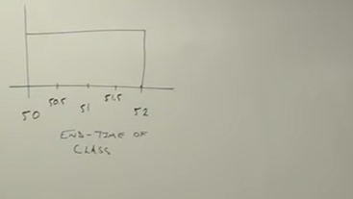

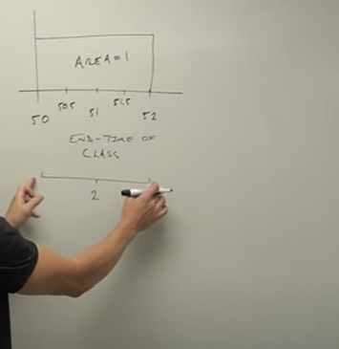

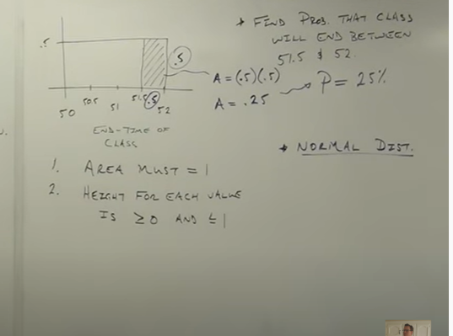

Normal distribution

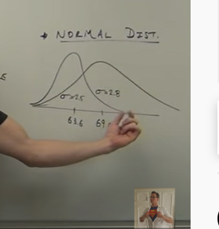

1st graph : women height

2nd men

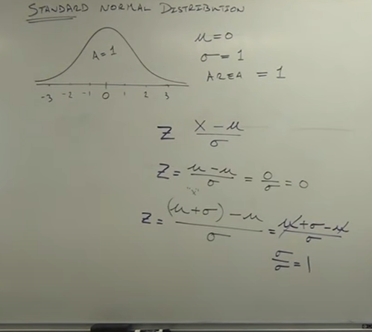

Standard normal distribution will work with data which is normally distributed

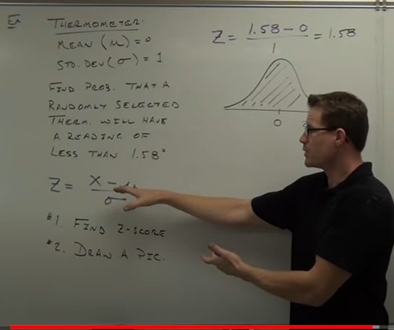

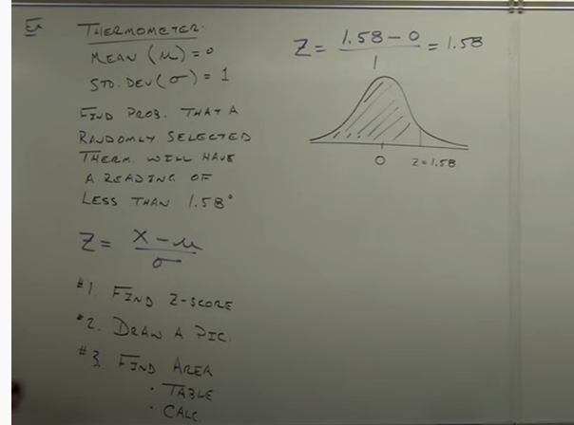

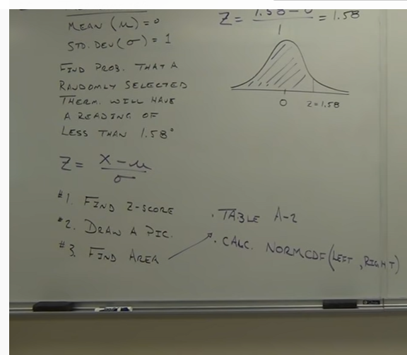

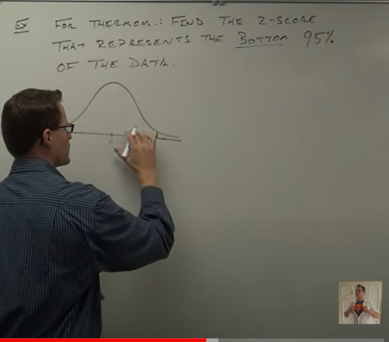

Bottom 95% means 95% of data below that value

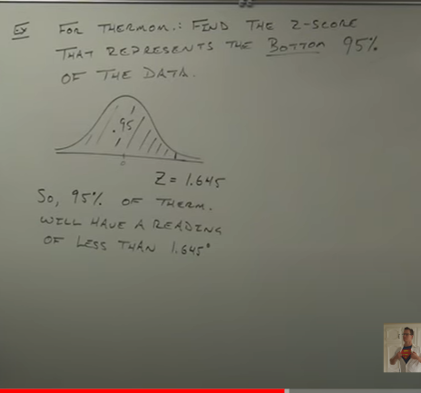

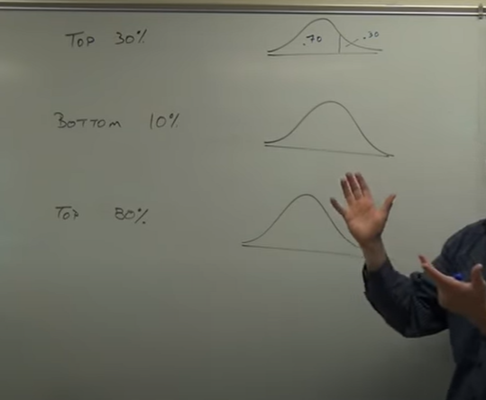

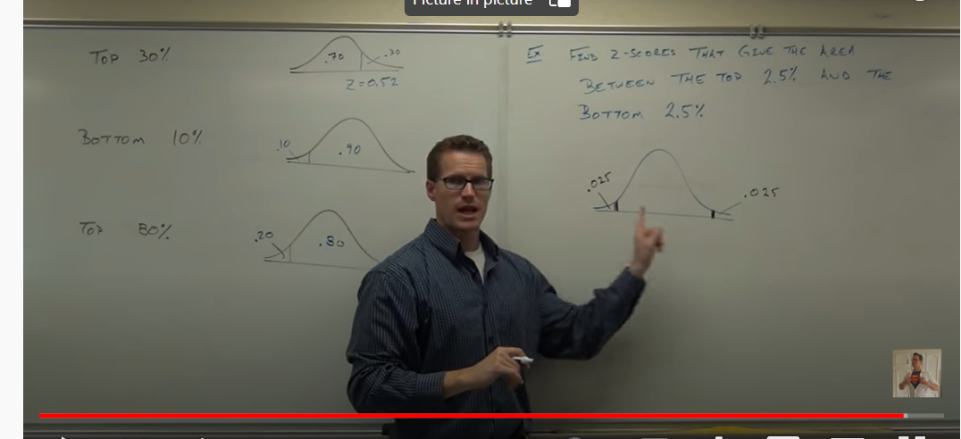

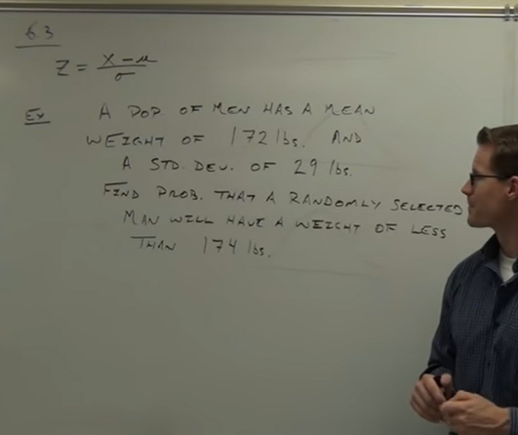

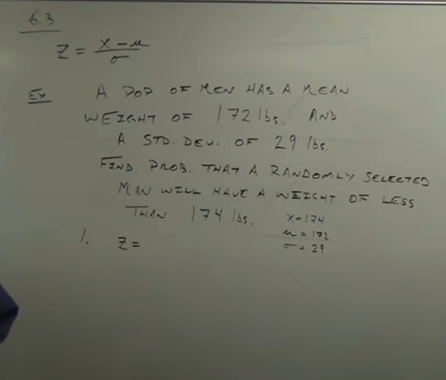

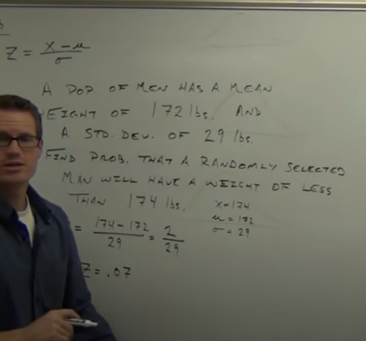

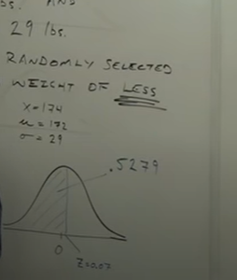



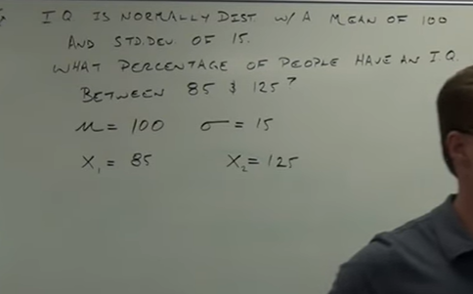

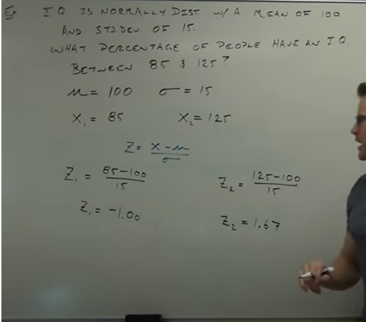

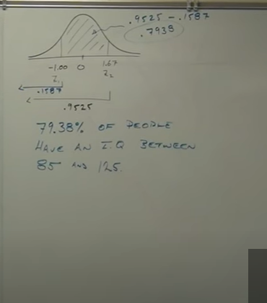



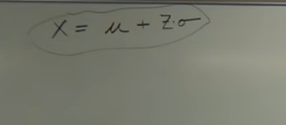

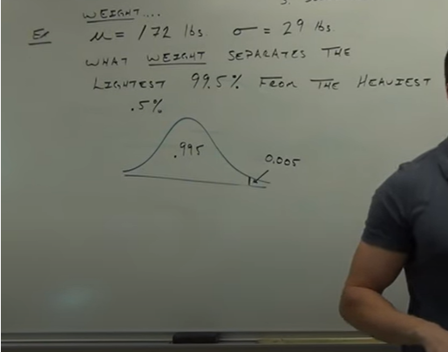

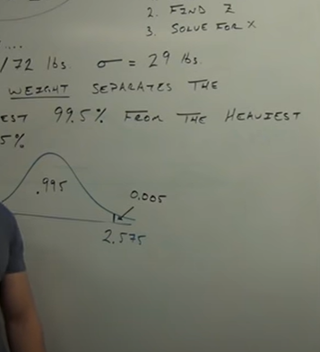

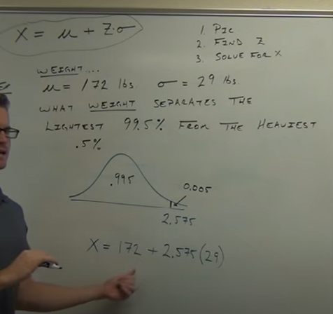

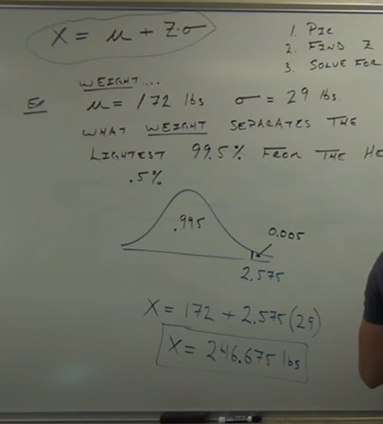

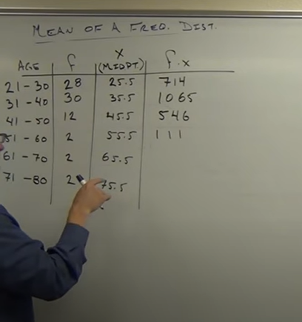

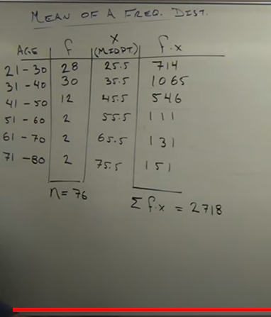

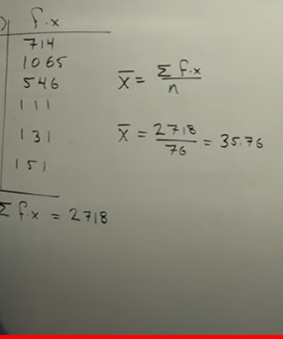

Weighted mean:

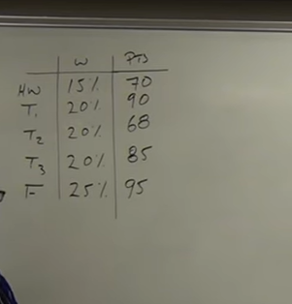

Variance: how data is spread

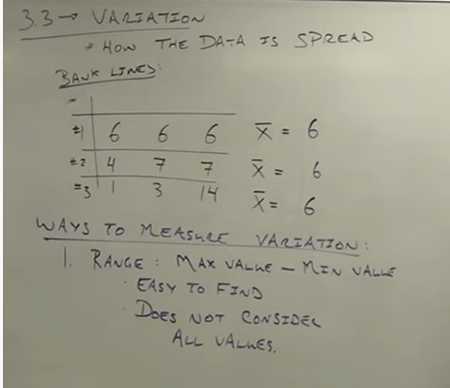

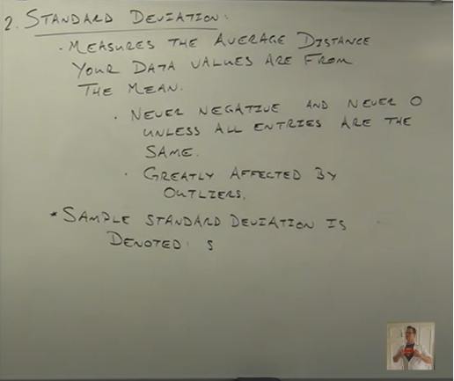

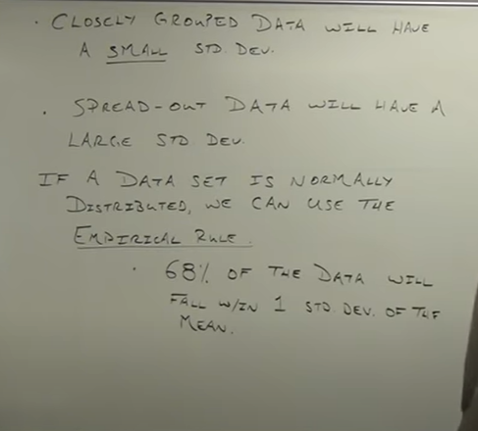

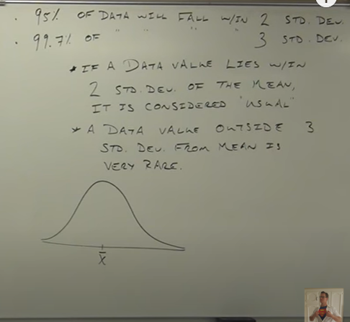

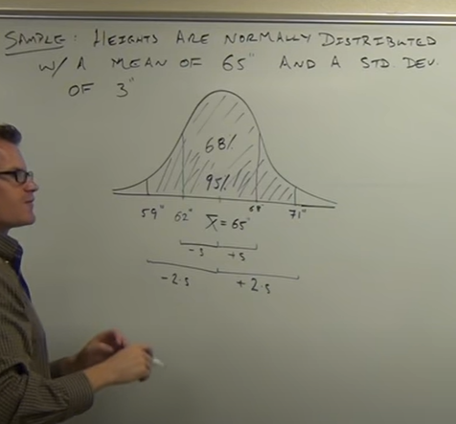

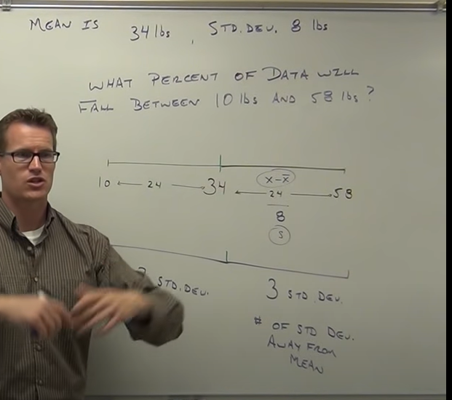

**Measures of relative standings:**

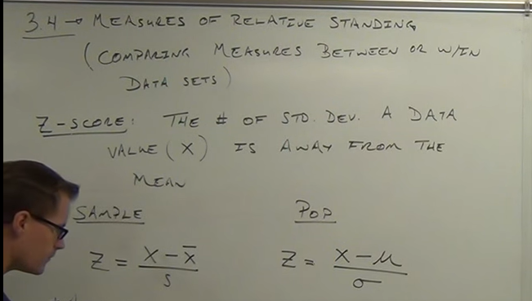

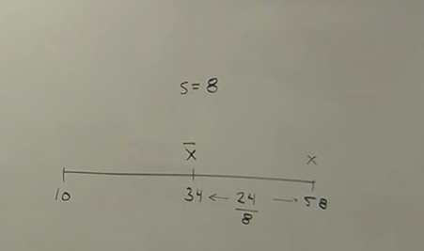



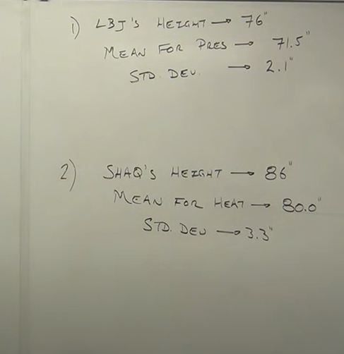

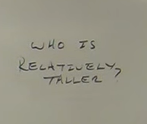

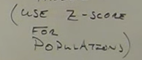

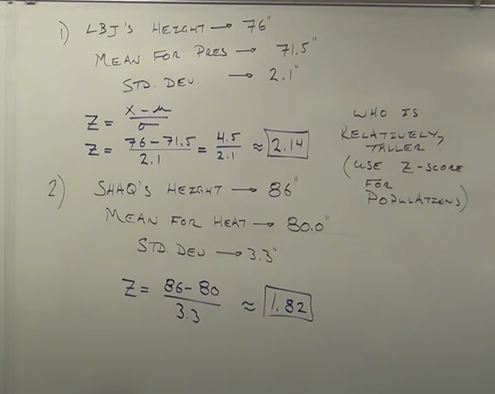

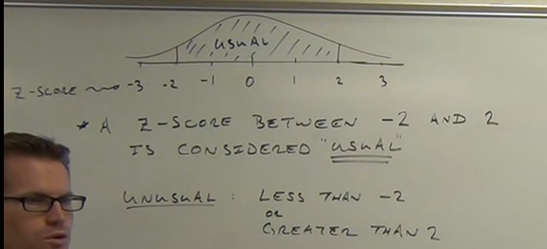

**Shaq = usual**

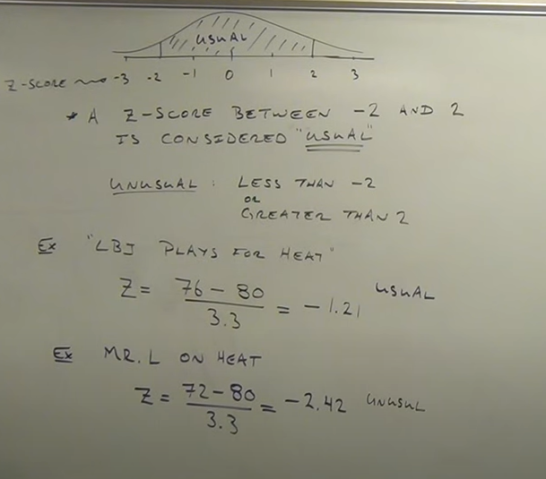

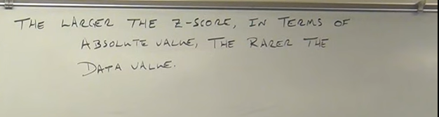

**Quartile: separate data into 4 parts**

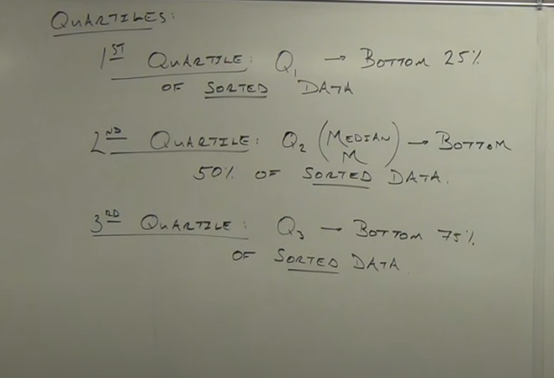

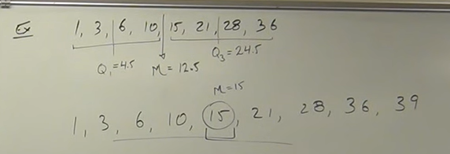

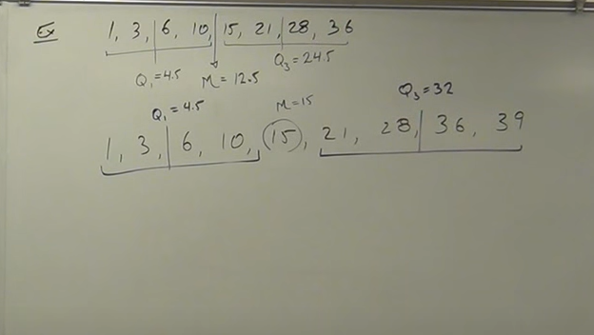

**Percentile:**

Devide data into 100 parts

**55 percentile : 55 parts below it**

**Percentile compare where u are out of everyone in same group**

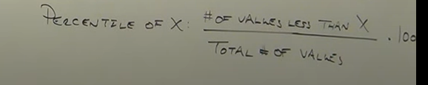

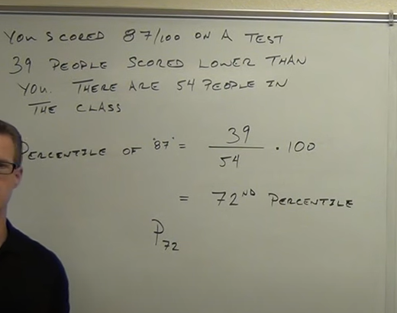

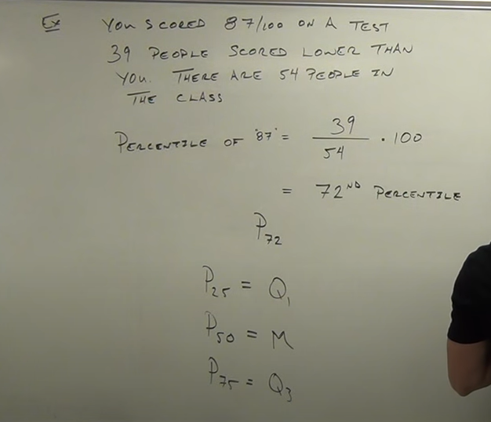

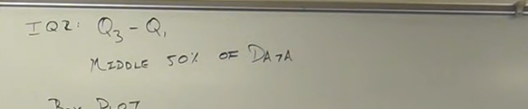

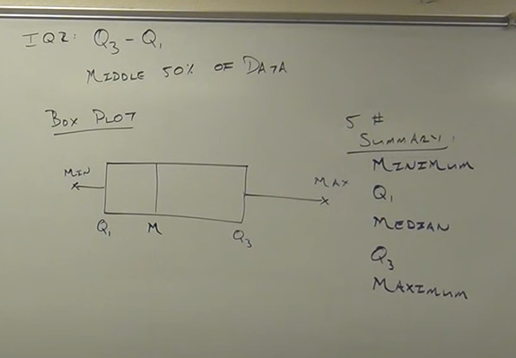

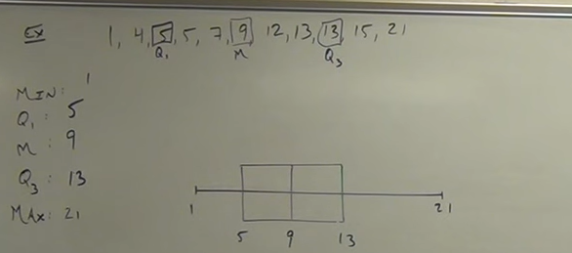

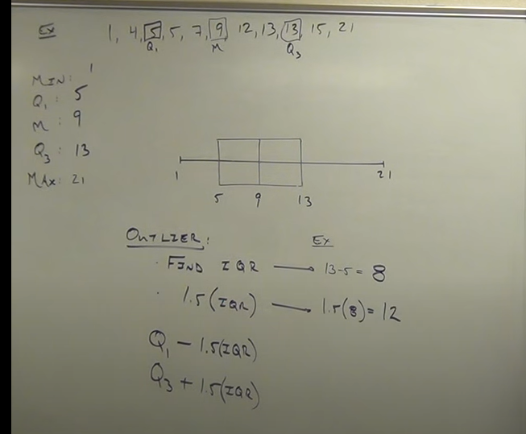

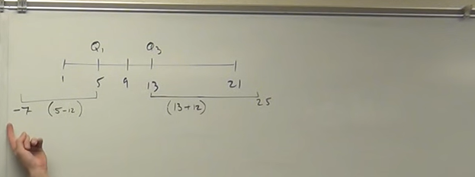

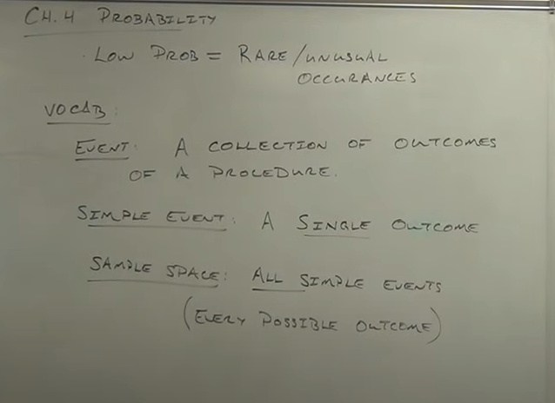

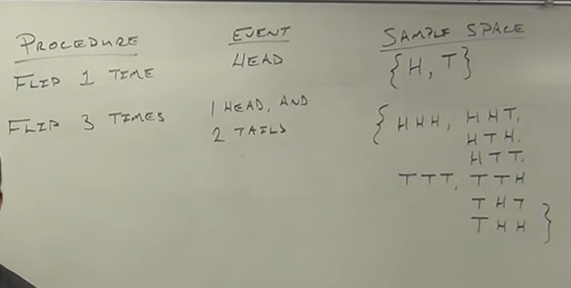

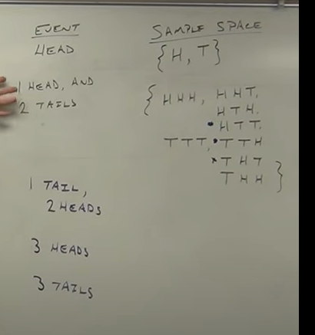

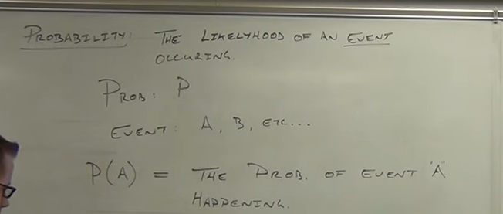

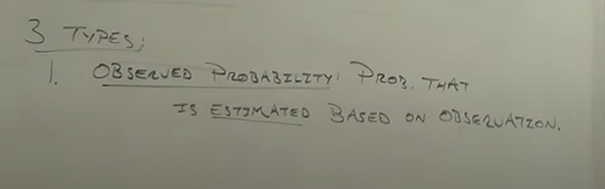

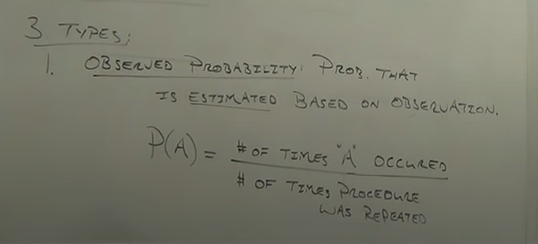

**Observed: what did happen, what will happen**

**Hitting a ball**

**Classical: what should happen**

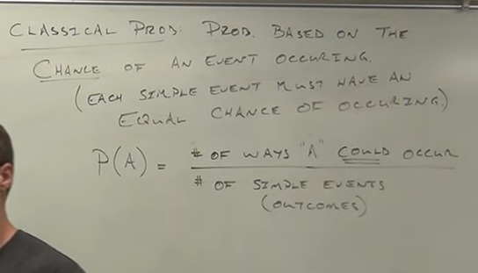

Subjective probability:

Everyday

Doctor: chances of death

Window: chances of window hit

Educated guess

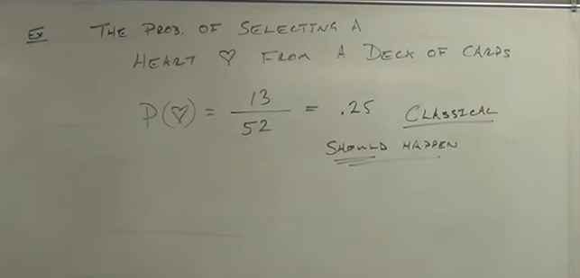

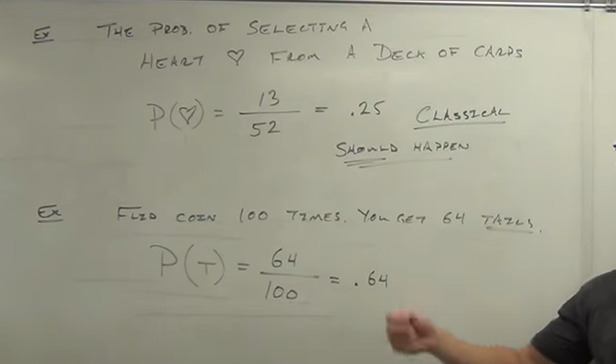

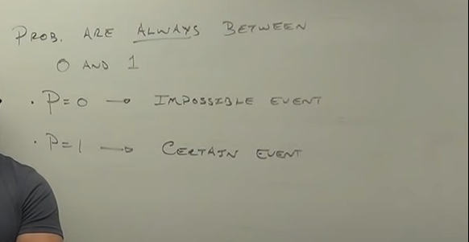



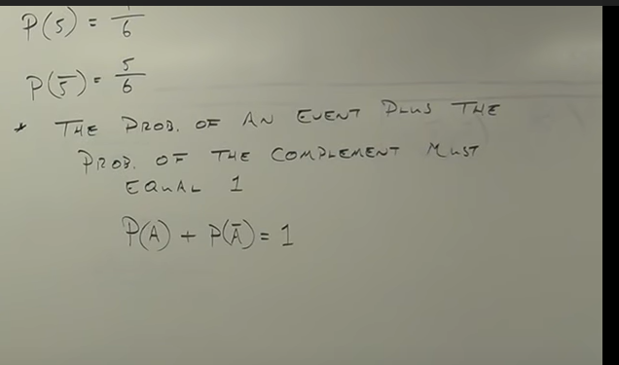

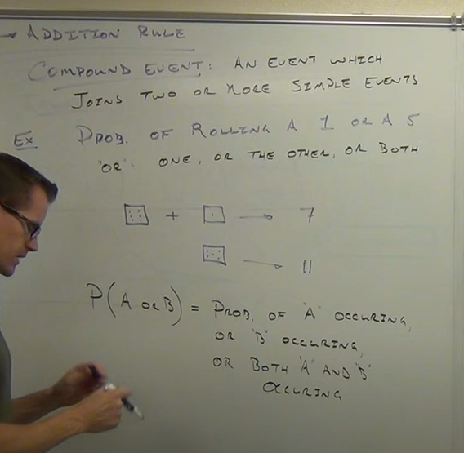

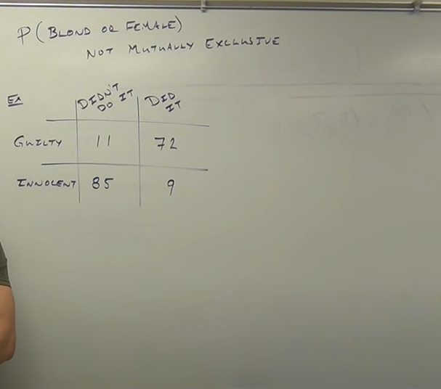

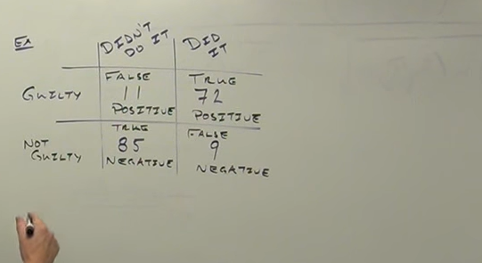

How many or did it or genuine

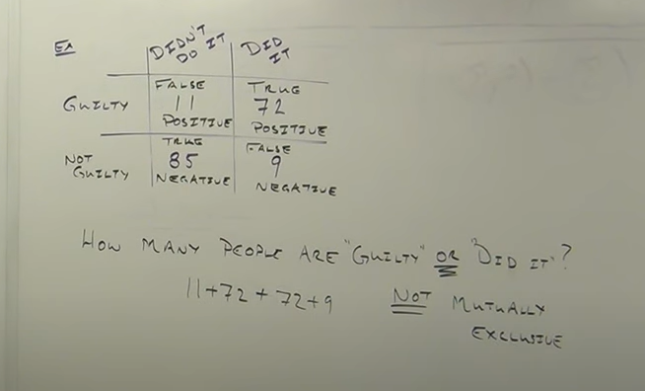

72 two times came

It should not come’

Either guilty or did it

But not both guilty and did it

11+72+9=92

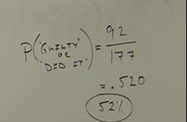

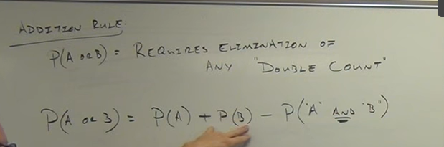

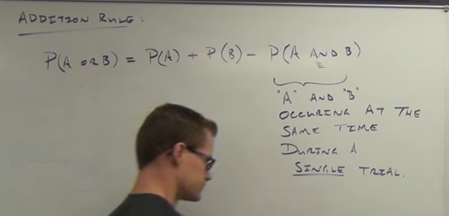



I and 5 happening in a roll of dice

Heart and diamond at a same time

Female and male

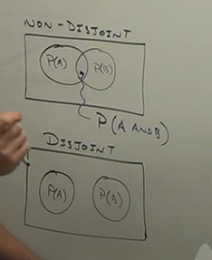

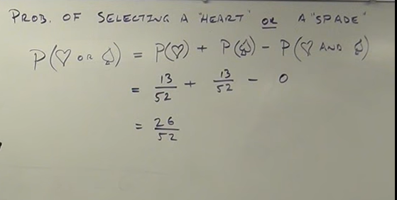

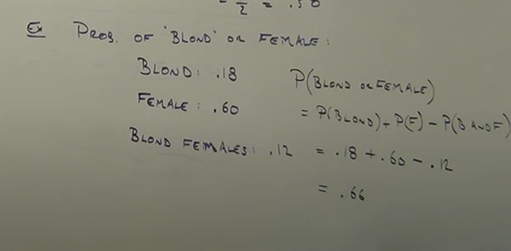

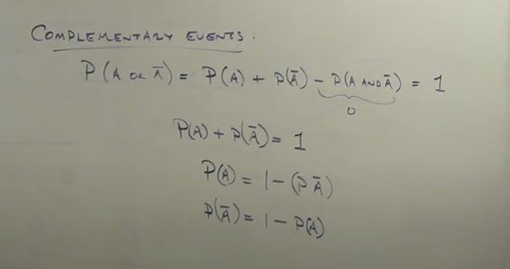

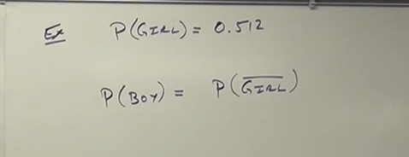

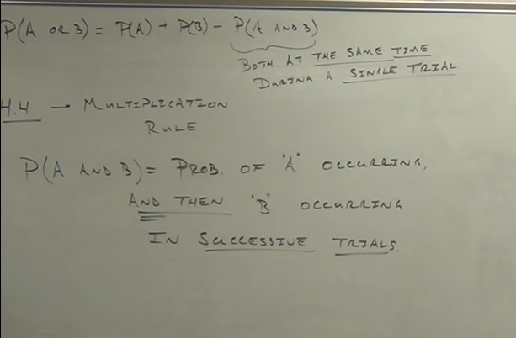

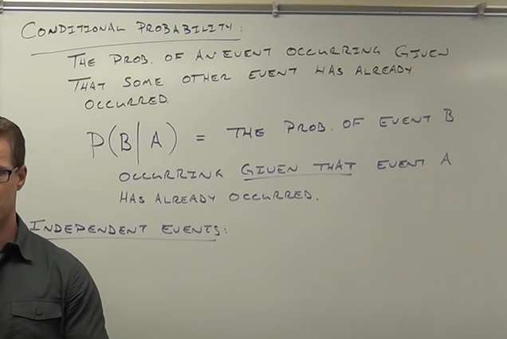





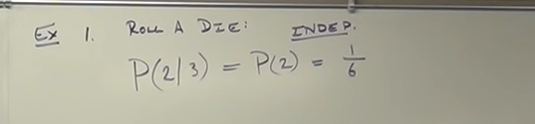

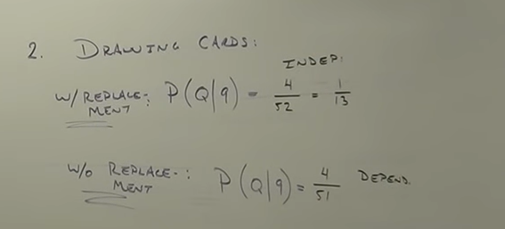

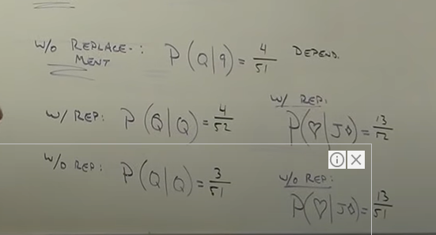

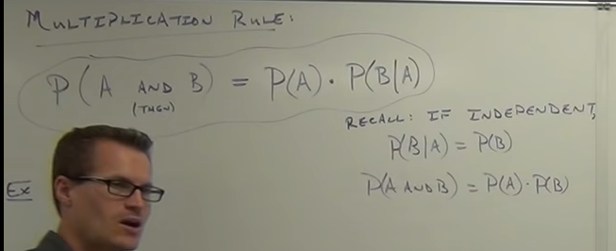

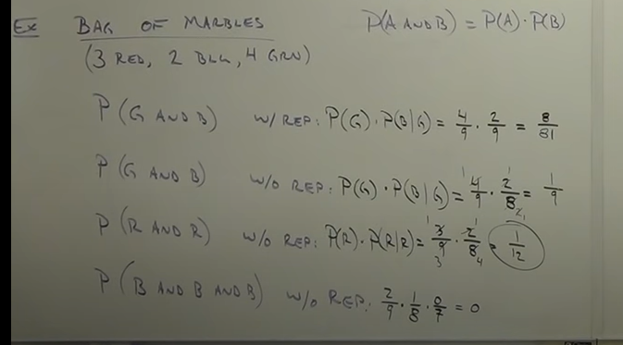

Dice: independent events

Will not effect

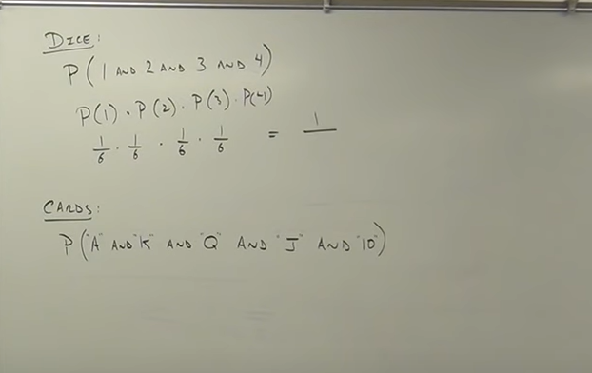

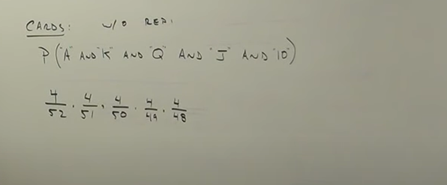

Complementary events with at least one:

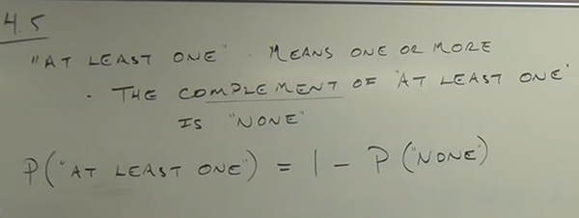

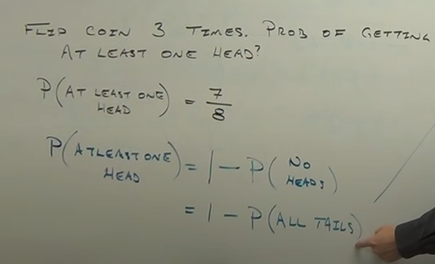

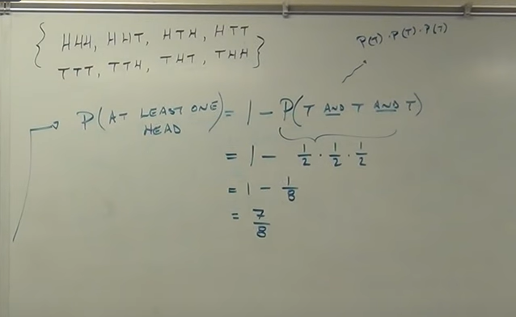

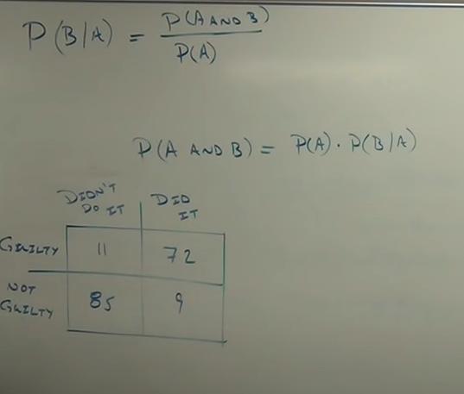

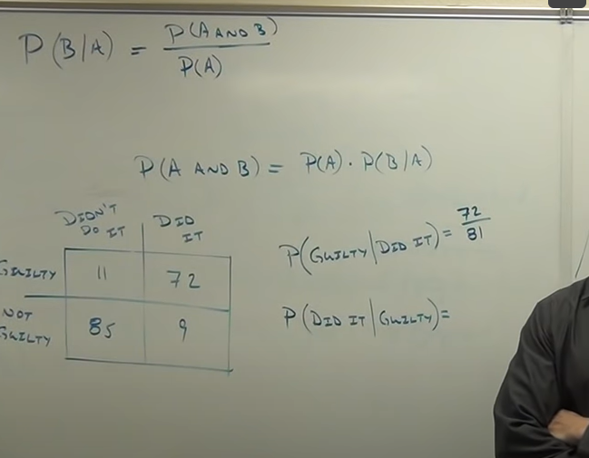

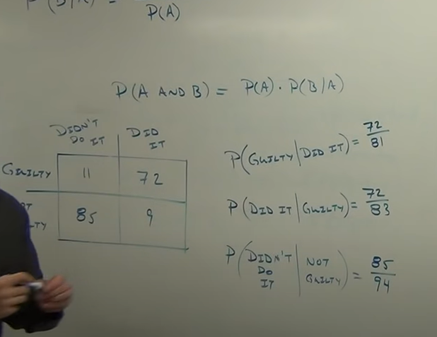

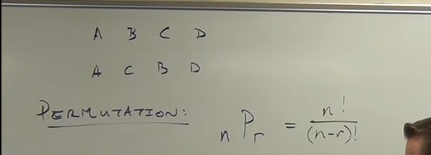

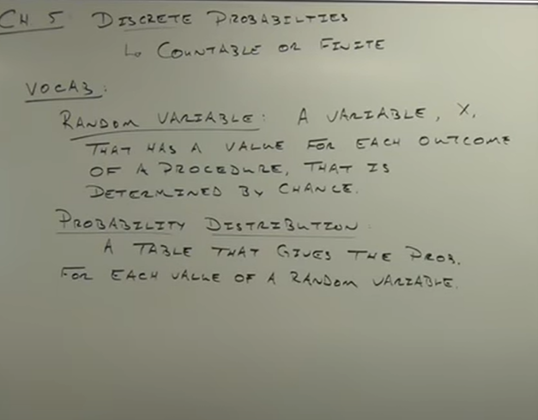

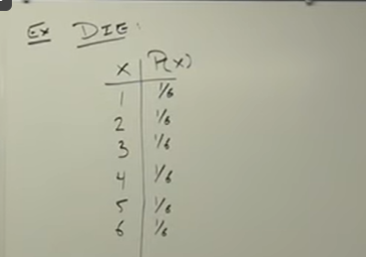

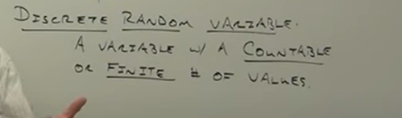

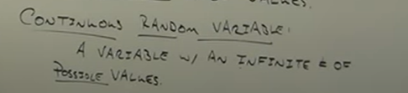

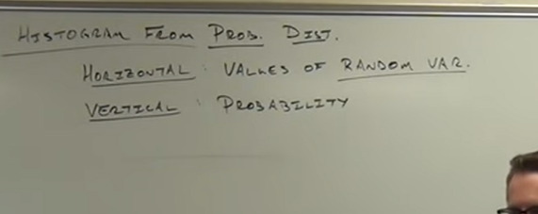

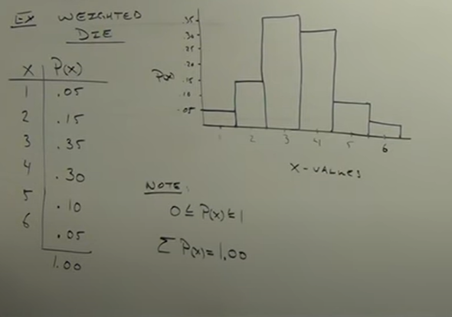



**Binomial probability distribution:**

**2 outcomes**

**Success or failure**

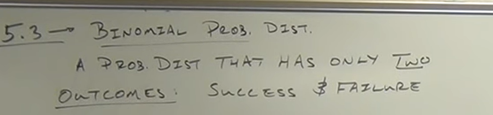

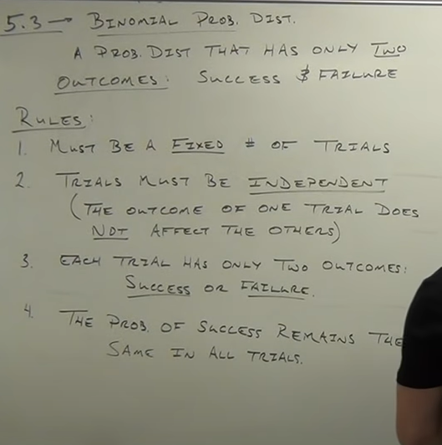

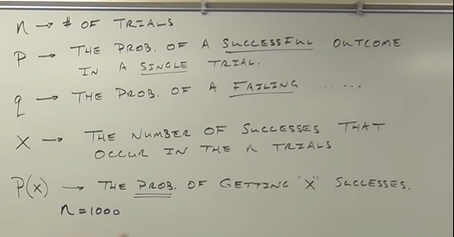

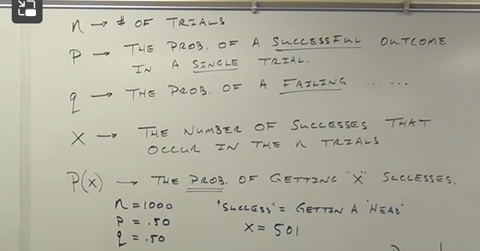

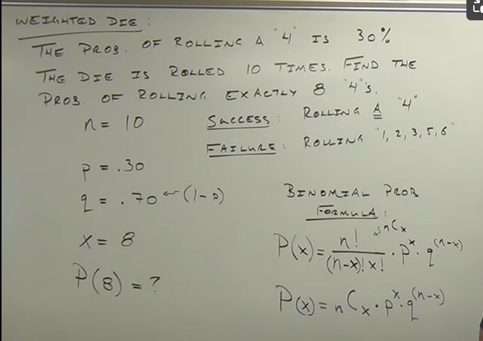

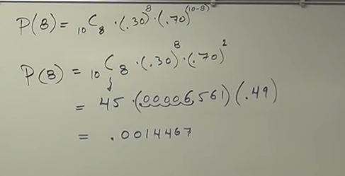

**Atmost 8 :**

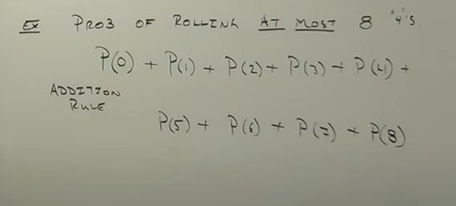

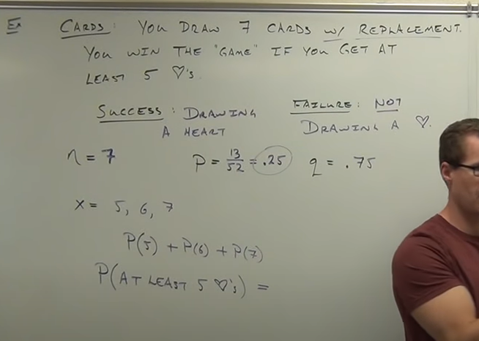

: **Finding Mean and Standard Deviation of a Binomial Probability Distribution**

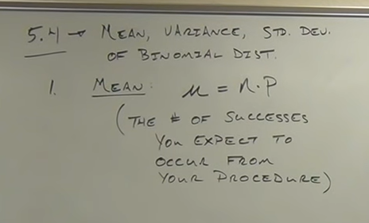

**n = total number of trials**

**p= probability**

**ex: dice**

**probability of 4 is .30**

**no of trial=100**

**mean= .30*100**

**variance: how faar your data got spread**

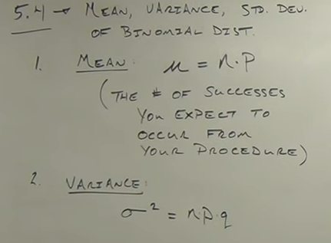

**Standard deviation:**

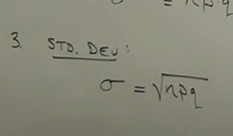

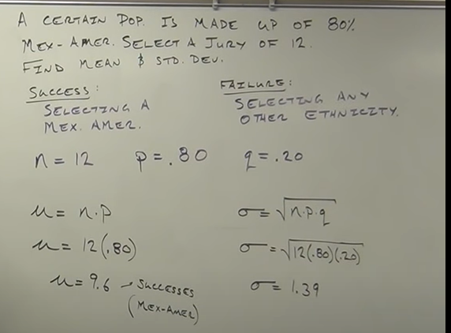

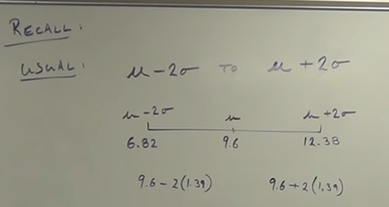

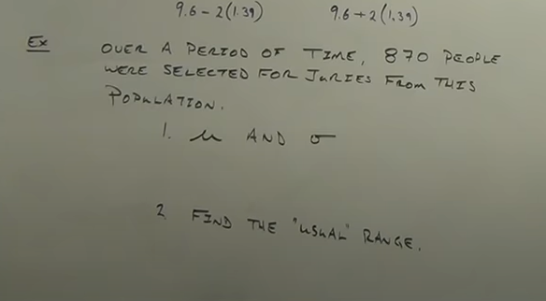

**Sampling Distributions Statistics. Using Samples to Approx. Populations**

**Idea to use sample statistics to estimate population**

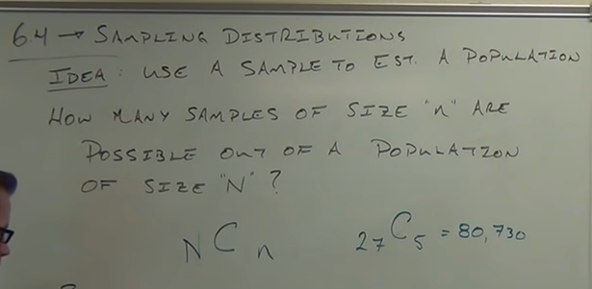

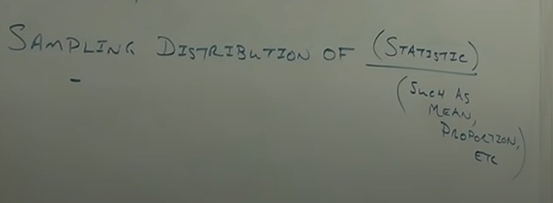

**Sampling distribution takes all statistics of different samples and arrange them in a table**

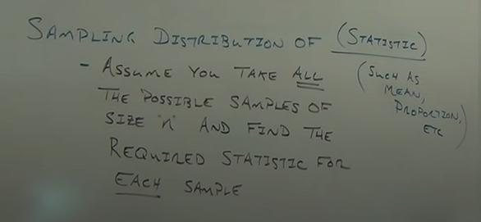

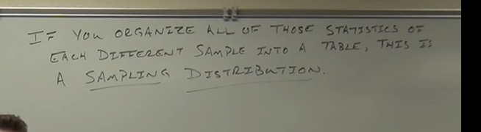

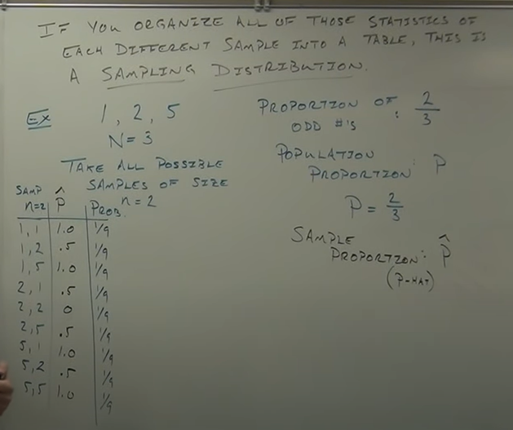

**Sample proportion p hat= num of odd/total number in sample**

**1,1== 2/2=1**

**1,2==1/2=0.5**

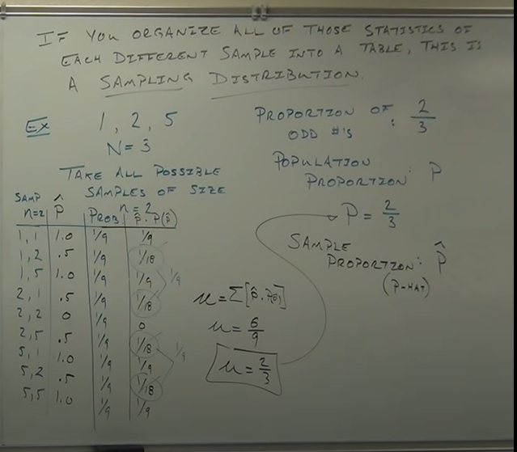

**Every sample proportion may not br equal to population proportion**

**But avg of all sample proportion equal to population proportion**

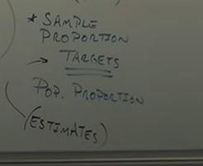

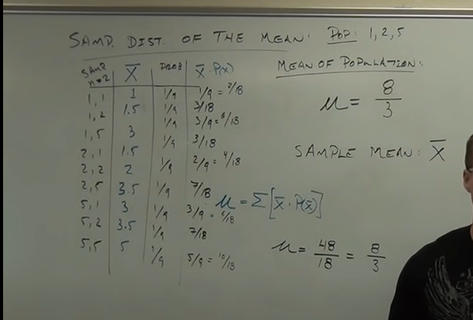

**Central limit theorem**

The Central Limit Theorem for Statistics. Using z-score, Standard Score

If sample size more than 30, whatever the population distribution (horizontal, skewed or normal) but all means of sample distribution is normal

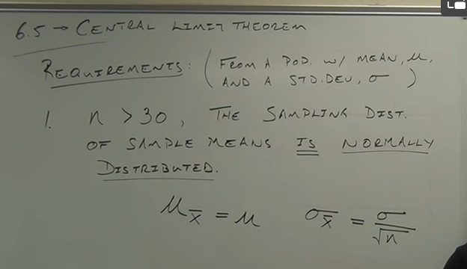

n is sample size

Standard deviation of samples means will be very less than population s.d, its depends on sample size

If sample size increases s.d of samples will be decreased

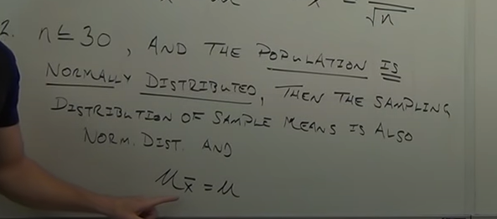

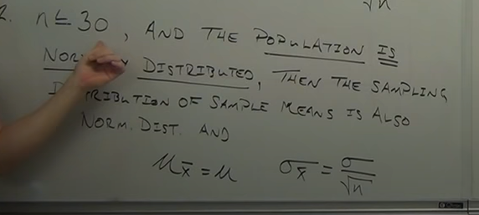

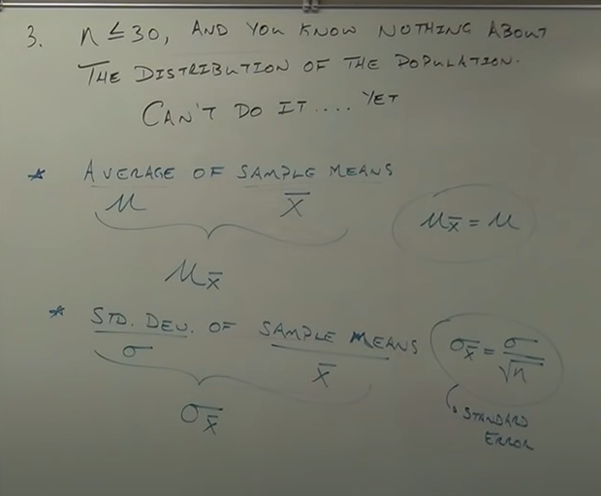

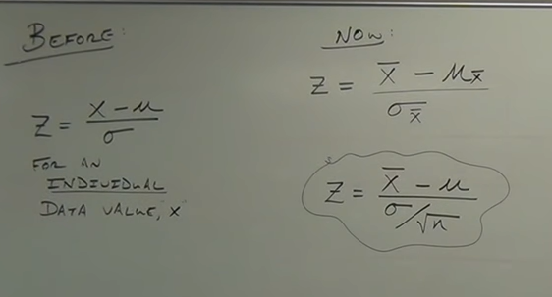

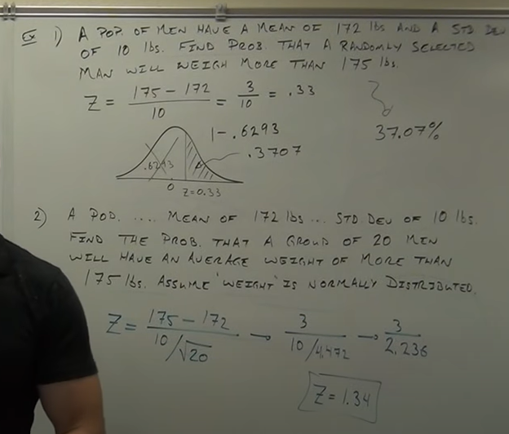

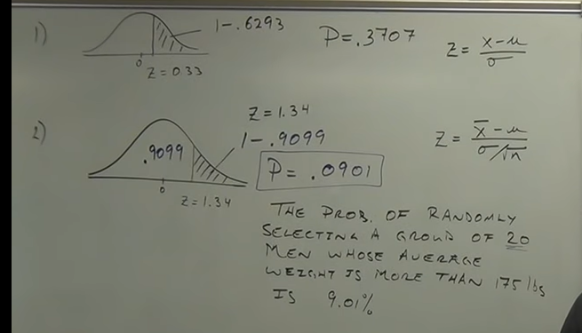

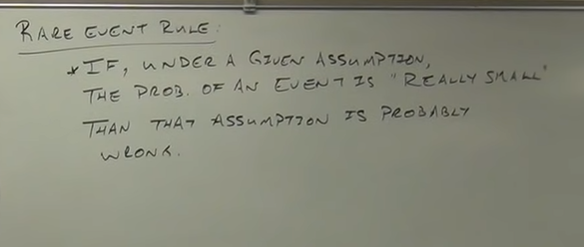

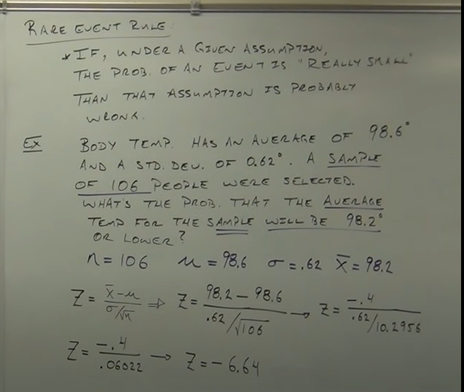

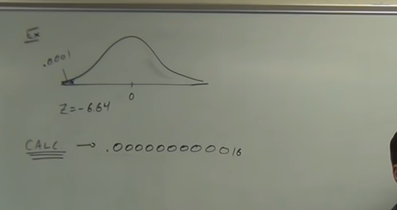

Finding Confidence Intervals for the Population Proportion

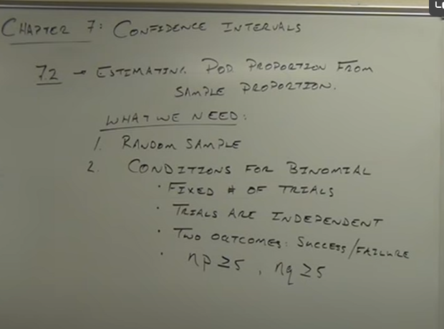

**Point estimate: single value from sample estimates entire population**

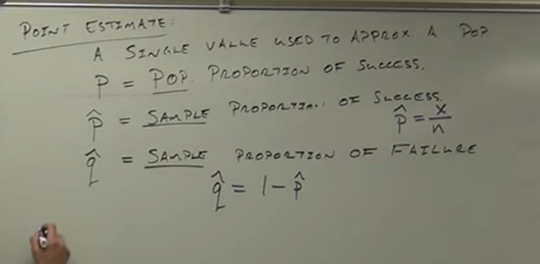

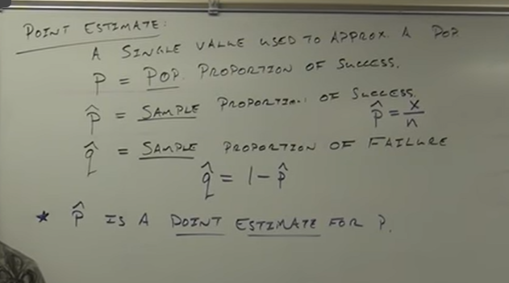

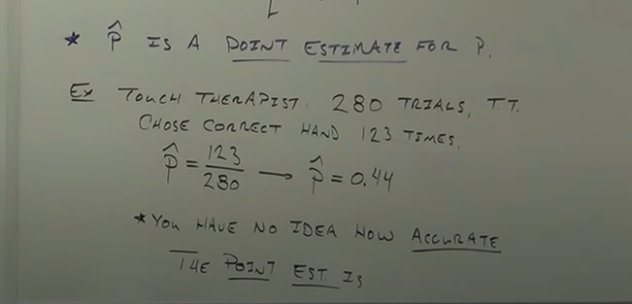

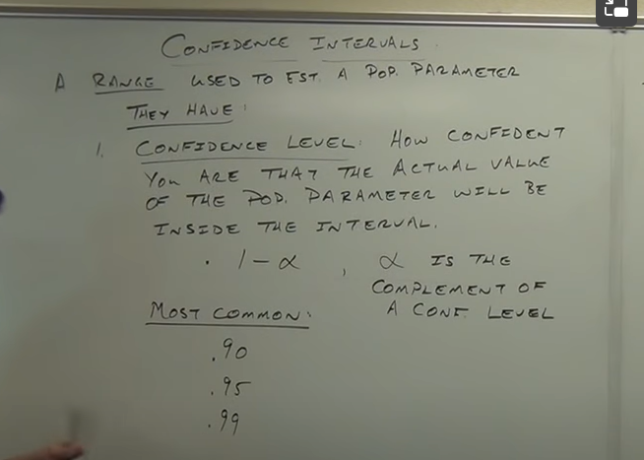

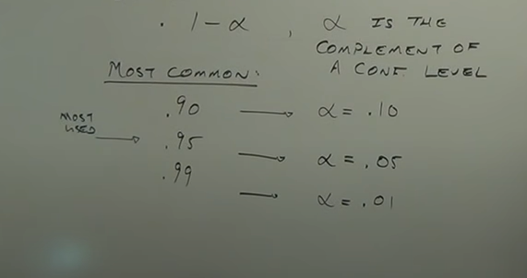

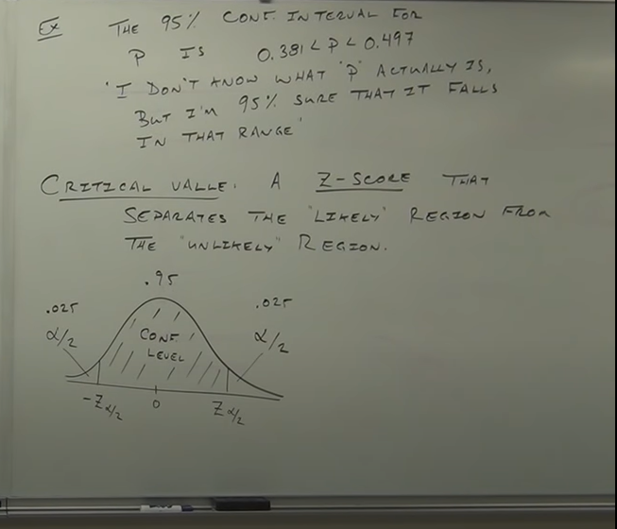

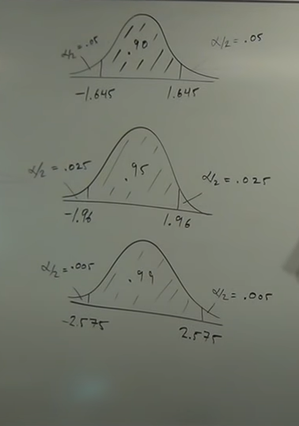

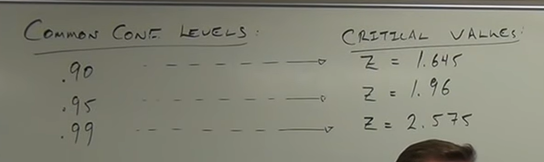

**More confident: larger error**

**Less confident : small error**

**Critical value : says max range**

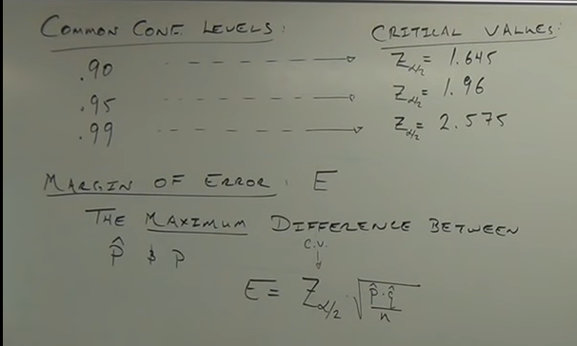

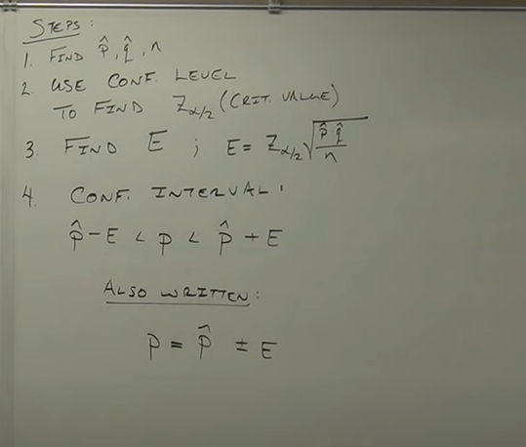

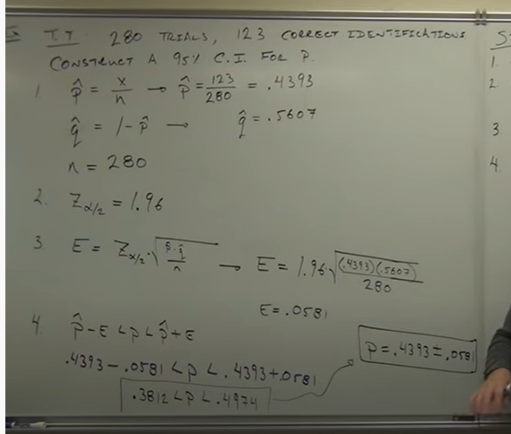

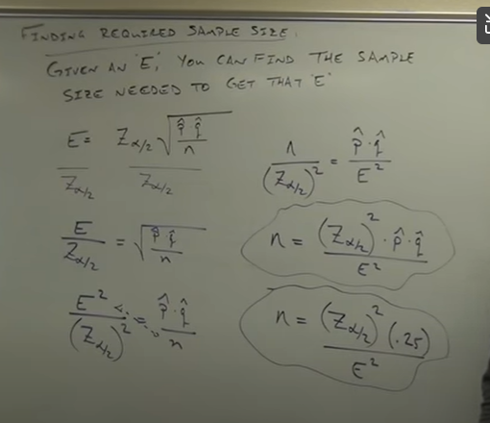

**.25 is becoz worst case scenario where u don’t know exact values of p hat and q hat**

